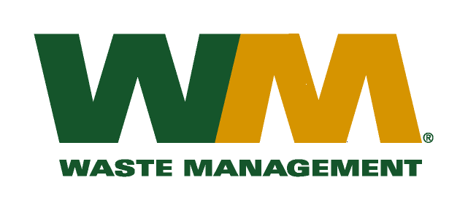

June 3, 2010

Washington Utilities and Transportation Commission

Chandler Plaza Building

1300 S. Evergreen Park Drive SW

P.O. Box 47250

Olympia, WA. 98504-7250

Dear Sirs:

Subject: Waste Management – Northwest; Docket TG-100930

Please find enclosed substitute tariff page 2 to Waste Management – Northwest Tariff No. 17. This page is submitted in accordance with Staff recommendations. Please do not re-docket.

If you have any questions or need additional information, please contact me at (425) 814-7840.

Respectfully,

Michael A. Weinstein

Senior Pricing Manager, Pacific Northwest Market Area