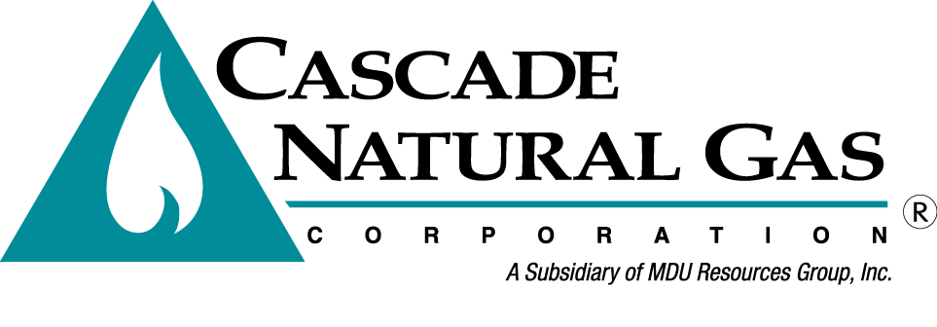 | 8113 W. GRANDRIDGE BLVD., KENNEWICK, WASHINGTON 99336-7166  TELEPHONE 509-734-4500 FACSIMILE 509-737-7166  www.cngc.com
VIA ELECTRONIC MAIL
records@utc.wa.gov

July 10, 2015

Records Center
Washington Utilities and Transportation Commission
1300 S. Evergreen Park Drive SW
Olympia, WA 98504

Re: UG-151380 – DO NOT RE-DOCKET
Advice No. CNG/W15-07-01 - Replacement Filing

Cascade Natural Gas Corporation (Cascade or the Company) filed Advice No. CNG/W15-07-01 docketed in UG-151380 on July 1, 2015. This submission replaces that filing in its entirety.

The Company herewith files the following revision to its Tariff WN U-3, stated to become effective with service August 1, 2015:

Eleventh Revision Sheet No. 9

The purpose of this filing is to revise Rule 5, “Notification of and Discontinuance of Service” to clarify the language in section (b) which states that the Company may disconnect service for nonpayment no sooner than eight days after the due date on the bill and that the Company will notify customer prior to disconnecting them for nonpayment. These changes are consistent with the requirements in (WAC) 480-90-128(6)(a)(i).

For improved readability, a minor wording change is made to section (f).

If you have any questions regarding this report, please contact me at (509) 734-4593.

Sincerely,

Michael Parvinen
Director, Regulatory Affairs

