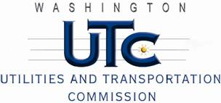

Memorandum

June 10, 2011

To: TR-100192 - File

From: Kathy Hunter, Deputy Assistant Director Transportation Safety

Subject: TR-100192 City of Spokane Valley

Grade Crossing Protective Fund (GCPF) Project at the Intersection of

Park Road and BNSF Railway’s Tracks in the City of Spokane Valley, Washington

On March 25, 2010, the Washington Utilities and Transportation Commission (Commission) awarded a GCPF grant in the amount of $40,000 to install medians at two crossings located on Park Road. On December 2, 2010, the Commission extended the project completion date to April 29, 2011, per the City of Spokane Valley’s request. The scope of the project involves installing median barriers on the south approach which will be 100 feet in length and 90 feet in length on the north approach to the crossings. One hundred feet of medians will also be installed between the two crossings which will include a 12-foot gap for access to the rail yard for BNSF maintenance crews. “No U Turn” signs will be installed on both approaches to the 12-foot gap in the medians to discourage motorists from improperly turning at this location.

The USDOT number assigned to these crossings is 066378S and 066377K.

On June 6, 2011, the applicant, the City of Spokane Valley submitted a request for reimbursement pursuant to Commission order. On May19, 2011, Commission staff conducted a site visit and verified that the project is completed according to the specifications outlined in the order approving the grant. The City of Spokane Valley also provided photos of the completed upgrades with their request for reimbursement.

Please close this docket.