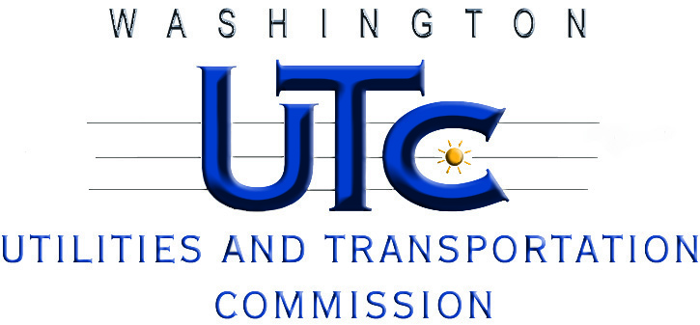

**Low-Income Conservation Inquiry Work Session**

**Docket U-101973**

**AGENDA**

**February 1, 2011, 1:30 PM**

1. Welcome, Opening Remarks by Commissioners, Introductions (1:30)
2. Presentation by Commission Staff (1:45)
3. Presentation by the Energy Project (2:15)
4. Other Stakeholder Statements (2:45)
5. Responses and Discussion of Topics from Notice of Workshop (3:15):

* What conservation results are being achieved by the low-income programs and what conservation opportunities may be going unrealized
* Barriers to conservation achievement specific to low-income conservation
* What are the current metrics for measuring the success of low-income conservation (costs test, groupings of programs for the cost tests, non-energy benefits, etc.)
* Other potential metrics and considerations for measuring the success of low-income conservation may be considered
* The need for policy statement given existing requirements in law, rule, and Commission practice for utilities to achieve conservation

1. Closing – Next Steps