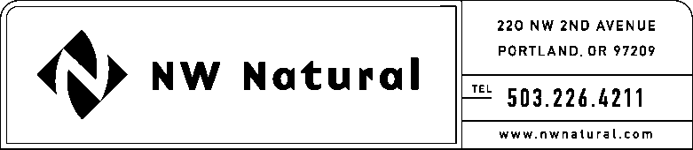
Shawn M. Filippi
Vice President, Chief Compliance Officer
and Corporate Secretary

Tel: 503.220.2435

Fax: 503.220.2584

e-mail: Shawn.Filippi@nwnatural.com

October 28, 2016

VIA ELECTRONIC FILING AND US MAIL
Steven King
Washington Utilities and Transportation Commission
1300 So. Evergreen Park Drive SW
P.O. Box 47250
Olympia, WA 98504-7250

Re: Docket UG-161164: NW Natural’s Statement Establishing Compliance and Request for Written Order Establishing Compliance with RCW 80.08.040 With Respect to the Proposed Issuance and Sale of Up to 1,700,000 shares of Common Stock
ERRATA FILING – DO NOT REDOCKET
On October 25, 2016, Northwest Natural Gas Company (the “Company”) transmitted for filing with the Washington Utilities and Transportation Commission (the “Commission”) a Statement Establishing Compliance (“Original Statement”) complying with RCW 80.08.040 and WAC 480-90-242, and a Request for a Written Order with respect to the proposed issuance and sale of up to 1,700,000 shares of its Common Stock. NW Natural herein files a correction to the Statement Establishing Compliance and Request for Written Order Establishing Compliance in the above-referenced docket. The errata changes the language on page 9 to read “As of the date of this Statement, the Company’s long-term secured debt is rated “A1” by Moody’s Rating and “AA-” by Standard & Poor’s (S&P), the Company’s unsecured debt is rated “A3” by Moody’s and a Corporate credit rating of “A+” by S&P, and a stable credit outlook by Moody’s and a stable credit outlook by S&P.” The Original Statement inadvertently incorrectly stated that the long-term secured debt was rated “A+” by S&P.
If you have any questions, or if you require additional information in support of this Statement Establishing Compliance and Request for Written Order, please give me a call at 503-220-2435 or email at smf@nwnatural.com.
Very truly yours,
/s/ Shawn M. Filippi
Shawn M. Filippi
Enclosure
cc w/Encl: Brody J. Wilson
Mark Thompson

