March 21, 2017

VIA ELECTRONIC FILING

Steven V. King
Executive Director and Secretary
Washington Utilities and Transportation Commission
1300 S. Evergreen Park Dr. SW
PO Box 47250
Olympia, Washington 98504-7250
Re: CenturyLink transfers of Control
Docket UT-170042
Dear Mr. King:
Enclosed for filing in the above-referenced docket is Exhibit A to the Protective Order signed by Mark P. Trinchero, along with a Certificate of Service.
Very truly yours,
Davis Wright Tremaine LLP
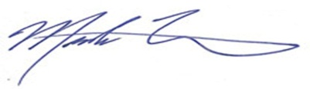
Mark P. Trinchero

MPT/jan

Enclosure

cc: Service List, via email

