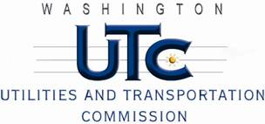

Memorandum

June 26, 2013

To: TR-121745 - File

From: Betty Young, Compliance Investigator, Transportation Safety

Subject: TR-121745 – Washington State Department of Transportation

Grade Crossing Protective Fund (GCPF) project to modify a railroad-highway grade crossing at SR-27/First Street in Oakesdale, USDOT #058580G

On November 13, 2012, the Washington Utilities and Transportation Commission (Commission) awarded the Washington State Department of Transportation (WSDOT) a GCPF grant in the amount of $20,000 to modify and improve active warning devices at the SR-27/First Street crossing in Oakesdale. The USDOT is #058580G. The total project cost was $59,845.56 with WSDOT paying for all costs exceeding that amount.

On June 26, 2013, WSDOT submitted a request for reimbursement for work pursuant to Commission order. Because the commission does not currently have its own signal inspector, Bryan Morris, a certified FRA signal inspector, conducted a site visit on June 21, 2013, and verified that the project was completed according to the specifications outlined in the order approving the grant.

Please close this docket.