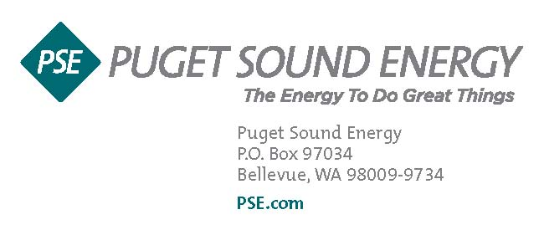

Customer Name

Customer Address

City, State, Zip

Dear Customer,

With the end of the production metering year approaching on June 30th, we are working to ensure that you receive your production payment as quickly as possible.

As a PSE participant in the Renewable Energy Cost Recovery Program, we will be preparing and sending you the required annual application in early August. Please note that the August 1st deadline provided by the Washington State Department of Revenue is intended for those who prepare the application themselves and does not apply to you.

If you are new to this program and would like to receive these funds via direct deposit instead of a check, please complete and return the attached ACH form as soon as possible. If you have provided this form previously but your banking information has changed, please complete and resubmit the form so we may update your records. Mail completed forms to the PO Box listed on the form for processing. If your banking and contact information has not changed from the information submitted last year, you do not need to do anything at this time.

To ensure a smooth and timely payment process, please save the dates below for your records.

***Dates to remember:***

**4/30/2016 –** Net Metering year ends. You will receive a statement shortly after this date to show the amount of credit left in your net metering bank as of 4/30. Per state law, your net metering bank will reset to zero after 4/30. This does not affect your state incentive for production metering.

**6/30/2016 –** Production year ends. Your production incentive will be determined based on the kilowatt-hour (kWh) production of your system between 7/1/2015 and 6/30/2016. The payment rate will depend on whether you have installed in state/out of state manufactured equipment. Additionally, per state law, production payments are limited to 0.5% of PSE’s taxable sales, which for 2016 will set the total payment pool at $10,055,598. Once we have a full count of all customers participating in the program and their production totals, we will be able to provide exact payment rates for this cycle.

**Early August 2016 –** Production information will be sent. You will receive a letter with your kWh production total and payment rate for your system. You must respond to this letter to receive your production payment**.** If you see any issues with this information you will need to let us know – if not, sign and return this letter and we will work to process your payment.

**Mid October – Mid December 2016 –** Production checks mailed.

**What we need from you:**

* If your contact information or mailing address has changed, please email me at [cj.conner@pse.com](mailto:cj.conner@pse.com) or call me at 425-456-2473.
* If you no longer own this home, please email or call me so that we can remove you from the program and add the new homeowner.

In summary, we will start calculating production numbers after the end of the production year on 6/30/16 and will have the applications out to you in early August. If you are receiving letters or emails about missing information from me, please be sure to respond to these quickly so we can include you in the 2015/2016 production payment. If you have any questions regarding the Renewable Energy Advantage Program or production payments you can read more at pse.com/reap, or feel free to contact me anytime.

Thanks,

**CJ Conner**

**Renewable Energy Program Coordinator**

**Puget Sound Energy**

**(425) 456-2473**

PSElogo