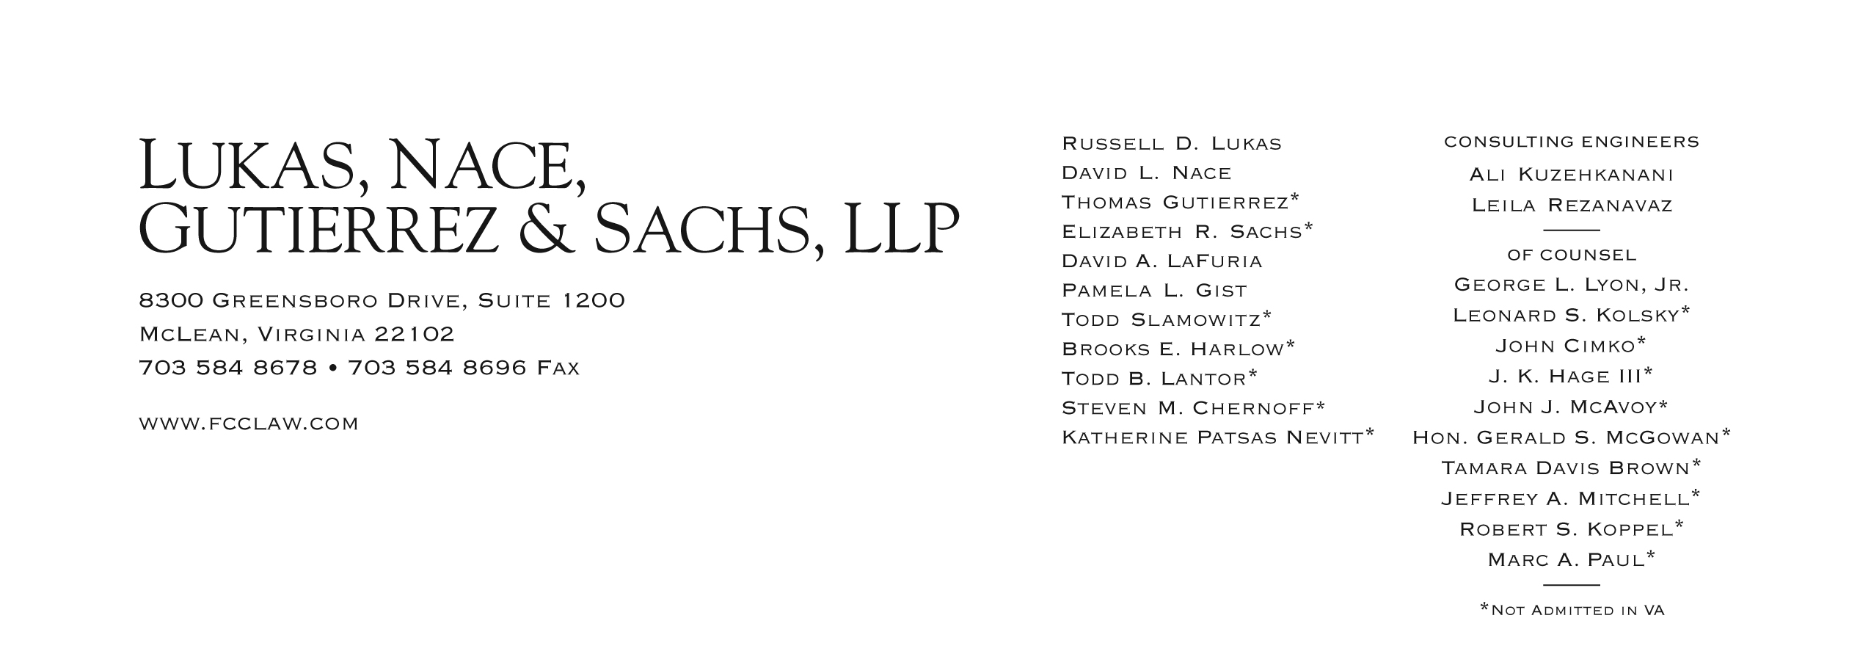

Brooks E. Harlow

(703) 584-8680

bharlow@fcclaw.com

February 16, 2012

VIA WUTC ONLINE RECORDS CENTER

ORIGINAL VIA U.S. MAIL

David Danner, Executive Director and Secretary

Washington Utilities and Transportation Commission

Attention: Records Center

P.O. Box 47250

1300 S. Evergreen Park Dr. SW

Olympia, WA 98504-7250

**Re: Docket No. UT-120052  
Investigation of Recent Developments in Federal Low Income Support Policy**

Dear Mr. Danner:

We file this letter on behalf of Budget PrePay, Inc. (“Budget”), in response to the questions issued in the above-referenced docket. Budget appreciates the Commission’s and Staff’s prompt follow up on the FCC’s February 6, 2012, Report and Order and Further Notice of Proposed Rulemaking (FCC 12-11, WC Docket No.11-42, *et al*.)(hereafter “*FCC Order*”) reforming the federal Low Income Support programs. Budget looks forward to participating in the Commission’s workshop on February 22, 2012, to assist the Commission in implementing the *FCC Order* and coordinating state procedures to improve the efficiency of the regulatory process as well as advance the public interest.

Budget provides the following preliminary and high level responses to the questions contained in the Commission’s February 7, 2012 Notice of Workshop. During the workshop, Budget may expand on these points and as part of the collaborative process may modify its positions as well.

1. *Should all wireless ETCs be required to use Department of Social Health Service (DSHS)’s Beneficiary Verification System (BVS)?*

Budget supports reasonable and efficient efforts to ensure that only qualified applicants receive Lifeline support and is interested in learning more about the status of BVS and the potential to expand access to wireless ETCs. Since the *FCC Order* also provides for establishment of a national verification system that should be operational in one to two years, that raises some questions about the efficiency of a Washington-only system. For example, will the DSHS be able to provide BVS access to wireless carriers before the federal system is operational? Does the DSHS have the resources to provided BVS to wireless carriers? Will the state defer to the federal system anyway when it is in operation, potentially requiring ETCs to implement two new and different systems within less than a two year period? Which system—federal or state—will be most effective and efficient for carriers? So, while Budget is open to participation in the BVS, it would like to learn more before committing to support it.

Importantly, if the Commission pursues this path, it should not delay granting new Lifeline ETCs applications while BVS is being expanded. Such delay would not be competitively-neutral, since several wireless Lifeline ETCs are already receiving support in the state.

1. *Is it feasible for the DSHS to provide access to BVS to all ETCs?*

Budget does not know the answer to this question but it may be an issue. We look forward to learning more at the workshop. State budgets and personnel time resources are generally constrained at this time, so expanding a program could certainly be problematic. See also comments re question 1.

1. *Should there be a mechanism to ensure that all ETCs check their customers’ eligibility either by using BVS or by checking proof documentation from customers before enrollment? For example, should all wireless ETCs be required to certify annually that they verify all their Lifeline customers’ eligibility before enrolling customers?*

The *FCC Order* was a great leap forward in establishing stronger provisions to ensure that only eligible customers receive support. *E.g., FCC Order*, ¶¶ 97-100. For ETCs that are able to access BVS—and if and when wireless ETCs are given access to BVS—the FCC Order requires the ETC to access the state database. *Id.* For now, wireless ETCs in Washington are only required to review consumer provided documentation of eligibility, since they can’t access the state database. *See id.* These requirements are reasonable and sufficient and the Commission should incorporate them without modification. See also comments to questions 1 and 2. It would not be unreasonable for CETCs to certify to the Commission annually that they are in compliance with the applicable FCC requirements.

1. *Should UTC, DSHS and all ETCs come up with an interim solution for duplicate Lifeline claims before the national database is fully implemented?*

Budget does not believe this would be practical or necessary. The FCC’s “National Lifeline Accountability Database” should be operational within a year. *See FCC Order*, ¶182. It is doubtful a state database could be set up much earlier and if it could it would be costly to the state and/or the carriers. The National Database will address the duplicate support issue and have the advantage of giving carriers a single point of contact and a single system to develop, learn, and maintain. Regardless of the decision on this question, new ETC designations should not be further delayed as it gives an unfair competitive advantage to the incumbent Lifeline CETCs.

1. *If so, what’s the best mechanism?*

*a. Should duplicate check be conducted before or after a customer’s enrollment?*

*b. Should the ETCs collectively select a third-party administrator to conduct the duplicate check?*

*c. How can we ensure a third-party administrator’s independence and accountability?*

*d. Will the DSHS be better suited to conduct the duplicate check?*

*e. What should be done once duplication is detected?*

*f. Who should pay to support the implementation of the interim solution?*

As noted, Budget does not support an interim state database, but is willing to listen to proposals by other parties, if any.

*In addition, the Commission invites interested persons to provide written comments on the following:*

1. *Currently, Eligible Telecommunications Carriers (ETCs) in Washington follow three different sets of customer qualification criteria based on whether they offer landline, prepaid wireless or postpaid wireless Lifeline service plans. Should the Commission unify customer qualification criteria for all customers? What are the pros and cons for a uniform set of customer qualification criteria?*

Budget encourages the Commission to move to unified criteria, consistent with the new rules and goals set forth in the *FCC Order*. As the FCC noted: “Uniform eligibility criteria would simplify the development of an eligibility database, an important tool in preventing ineligible consumers from enrolling in the federal program. Moreover, together with an eligibility database, uniform eligibility criteria will facilitate the auditing process because all ETCs will operate under a set of baseline rules.” *Id.,* ¶ 66. Further, “with uniform eligibility requirements, consumers will face more streamlined enrollment procedures, while there would be fewer regulatory burdens on service providers.” *Id.* The FCC rules will now, “require all states to utilize, at a minimum, the income and program criteria currently utilized by federal default states.” *Id*.

Budget understands the circumstances that lead to the three criteria in Washington, but with the implementation of the new safeguards in the FCC Order, it makes sense to transition to a single set of criteria consistent with the new federal criteria, particularly if the Commission decides to require or allow carriers to verify eligibility using the new federal database that will be established soon.

1. *By Commission’s ETC designation orders, all prepaid wireless ETCs are required to maintain direct contact with their Lifeline customers. What constitutes “direct contact” with consumers? What’s the role of commission-based agents who market Lifeline products for ETCs? Should those agents’ role be limited to advertising, distributing and collecting Lifeline application forms (not dispatching cell phones)?*

Under Budget’s current operational model, “direct contact” means that all certifications are reviewed by Budget trained employees before a handset is given to a customer. Here is how it works in the currently applicable scenarios:

a. Stores – employees review certification forms directly.

b. Web – once an order is placed an employee reviews the order for accuracy and completes order. The web also has safeguards for duplicates and fraudulent orders.

c. Customer Direct – for a direct mail piece a Budget-employed customer service representative will review the application for accuracy and complete order. Should a customer call into the call center a customer service representative will read a series of questions to the customer to determine eligibility.

d. Agents – a certification form is completed at the agent’s store and entered by the agent and then faxed. Once the Budget-employed customer service representative receives the fax, the certification is reviewed for accuracy and eligibility is determined before handset is shipped to customer.

While Budget does not currently permit agents to distribute phones, Budget does not think such a practice should be prohibited by rule. Budget would prefer the flexibility to change its practices to respond to the market. Nor has need for such a rule been established. The *FCC Order* will require greater documentation and accountability in the near term, plus database checks in the next one to two years, to ensure compliance. It would be premature to erect additional barriers to getting phones in the hands of eligible needy consumers before there is any demonstration of abuse under the new and substantially tightened FCC requirements.

1. *Should there be sanctions on inappropriate marketing behaviors? To what extent should the ETCs be held responsible for their agents or contractors’ inappropriate marketing behaviors?*

Budget does not believe new enforcement rules are needed. The Commission already has sufficient enforcement authority. *See, e.g*., RCW 80.04.380 *et seq*. Although the wireless ETCs may not be “public service companies,” enforcement statutes extend to “other corporations” and “persons.” RCW 80.04.387-390; *see also*, RCW 80.36.610. ETCs should be held responsible for the actions of their agents consistent with existing Washington law on agency.

1. *Should the Commission set parameters for ETCs’ Lifeline outreach and marketing behaviors? For example, is it appropriate to distribute cell phones at a carrier-sponsored event? Is it appropriate to solicit customers inside or in close proximity of social service agencies?*

Budget does not believe that any such targeted restraints on outreach are necessary or in the public interest. The overarching public interest goal is to reach as many eligible customers as possible. With the new FCC mechanisms to prevent duplicate and ineligible customers, further restrictions would only operate to reduce access to eligible consumers, which is not in the public interest.

1. *Many recent ETC petitioners are small companies focused solely on provision of Lifeline services. Should companies’ financial strength be a concern in staff’s evaluation of ETC applications? If so, what standards should apply?*

In this day and age there are numerous options for Lifeline service, so even a sudden failure of an ETC—which has rarely occurred—is not likely to cause significant harm to consumers. The risk to consumers does not merit creation of any undue barriers to entry, except possibly for carriers that require deposits or substantial prepayment for services. If the Commission does anything in this regard, it should merely mirror the new rules adopted in the *FCC Order. See id.,* 387-88 and Appendix A (adopted rules). Any such new requirements should be applied only prospectively newly filed applications.

We look forward to discussing the forgoing comments and those of other participants at the workshop next week.

Sincerely,



Brooks E. Harlow

CC: *via email only*

Brian Thomas

William Weinman

Jing Liu

David Donahue

Robin Enkey

Katherine King

Todd Lantor