November 19, 2013

**FILED ELECTRONICALLY VIA WEB PORTAL**

Mr. Steven V. King

Executive Director & Secretary

Washington Utilities and Transportation Commission

Post Office Box 47250

1300 S. Evergreen Park Dr. SW

Olympia, Washington 98504-7250

**Re: In Re Petition of Shuttle Express, Inc., for Exemption from WAC 480-30-213(2) and WAC 480-30-456, Pursuant to WAC 480-07-110**

Docket No. ___________

Dear Mr. King:

Please find enclosed for filing the Petition of Shuttle Express, Inc. forExemption from WAC 480-30-213(2) and WAC 480-30-456, Pursuant to WAC 480-07-110 and the Declaration of Jimy Sherrell in Support of Petition for Exemption. As noted in the Petition, consideration before December 12, 2013 is requested. Pursuant to WAC 480-07-140(1)(a), these documents are being filed electronically only. No paper copies will follow unless requested by the Commission.

If you have any questions please contact the undersigned.

Very truly yours,  
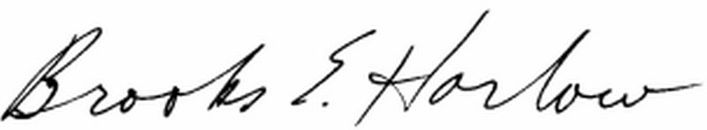  
Brooks E. Harlow, P.C.

Cc: Mr. Jimy Sherrell

Enclosures