October 5th, 2015

Mr. Steven V. King, Executive Secretary

Washington Utilities and Transportation Commission

1300 South Evergreen Park Drive SW

Olympia, WA 98504-7250

Re: Docket UT-151612, Petition to receive support from the Universal Service Communications Program

Dear Mr. King:

As a result of working with commission staff, please find replacement and supplement pages to Toledo Telephone Company, Inc., original petition dated July 30, 2015 to receive funds under the Universal Service Communications Program. The following replacement and supplement pages are enclosed:

Replacement Pages:

Cover Letter (WORD & PDF)

Petition (WORD & PDF)

Exhibits 2, 3 (WORD & PDF)

Exhibit 4 (EXCEL &PDF)

Exhibit 5, Audited financial statements (PDF)

Supplement Pages:

Signed Exhibits 7,8 and 9 (PDF only)

Sincerely

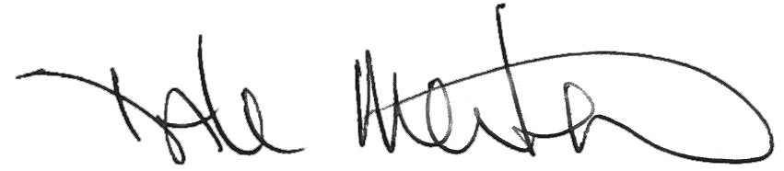

Dale Merten

Chief Operating Officer

Encl/