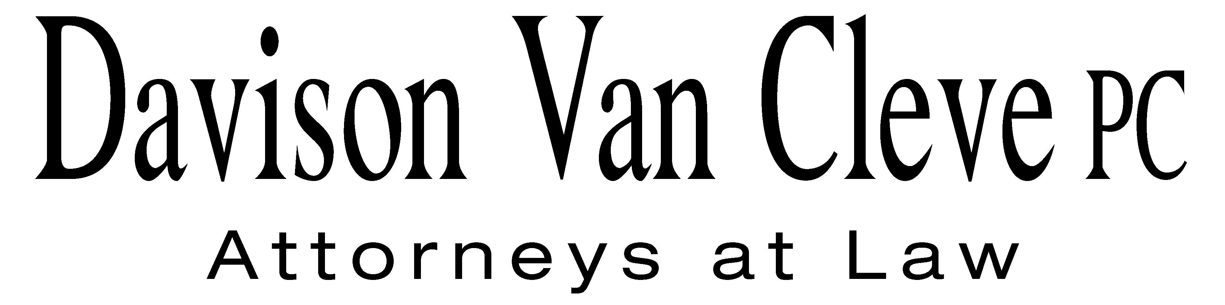  
TEL (503) 241-7242 ● FAX (503) 241-8160 ● mjd@dvclaw.com  
Suite 400  
333 SW Taylor  
Portland, OR 97204

March 27, 2015

***Via Electronic Mail and U.S. Mail***

Chairman Dave Danner

Commissioner Philip Jones

Commissioner Ann Rendahl

Washington Utilities and Transportation Commission

PO Box 47250

1300 S. Evergreen Park Drive, SW

Olympia, WA 98504-7250

Re: Washington Utilities and Transportation Commission v. Puget Sound Energy, Dockets UE-130617, *et al.*

Dear Commissioners:

The Industrial Customers of Northwest Utilities (“ICNU”) submits this letter in opposition to the settlement agreement concerning proposed changes to Puget Sound Energy’s (“PSE” or the “Company”) Power Cost Adjustment (“PCA”) mechanism, filed by PSE, Commission Staff, and Public Counsel (“Settling Parties”) on March 27, 2015. Pursuant to Order 06, ¶¶ 43-44 in these proceedings, ICNU participated in the PCA Review Collaborative (the “Collaborative”), along with the Settling Parties. Based on this Collaborative participation, ICNU believes that the proposed changes to the PCA are unnecessary and potentially harmful to ratepayers, and should be rejected by the Washington Utilities and Transportation Commission (“WUTC” or “Commission”).

The Settling Parties are proposing PCA changes which will have very significant effects on PSE’s deadbands and sharing bands, safeguards the Commission deems “critically important elements” to any power cost recovery mechanism designed to “protect ratepayers.” WUTC v. PacifiCorp, Docket UE-130043, Order 05 at ¶ 170 (Dec. 4, 2013). For example, the settlement will reduce PSE’s deadband to $17 million, making customers susceptible to additional surcharges in the first sharing band. Customer exposure is compounded by the fact that the Settling Parties have agreed to reduce the surcharge threshold, or trigger, to just $20 million.

Moreover, the proposed settlement would also shift a considerable portion of production costs into the Company’s decoupling mechanism in future rate cases. By its very terms, this represents a major change to PSE’s entire rate structure affecting all customers subject to the Company’s decoupling mechanism. Such significant changes should only be considered in the context of a general rate case. If this settlement is approved it will significantly change the scope of the decoupling mechanism. If such changes are permitted to the decoupling mechanism, ICNU once again requests that Schedule 40 electric customers be exempt from the decoupling mechanism.

Thank you for your consideration of ICNU’s concerns and opposition to the proposed settlement. ICNU believes this settlement will only serve to shift more risk and costs from PSE to ratepayers.

Sincerely yours,

*/s/ Jesse C. Cowell*

Jesse C. Cowell

cc: Sheree Strom Carson

Sally Brown

Simon ffitch