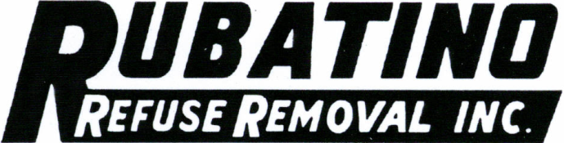 

December 15, 2008

Secretary

Washington Utilities & Transportation Commission

PO Box 47250

Olympia WA 98504-7250

RE: Certificate #G-58

Dear Secretary:

Enclosed please find the updates to our 13th proposed revised Check Sheet and the 10th proposed revised Page 22 issued November 15, 2008 as well as our Petition for Approval to Continue Existing Recycle Commodity Tracker. These revisions are due to adjustment in the annual recycling commodity credit. We are asking to amend the previous filing which was to become effective January 1, 2009 in favor of a six (6) month extension on the current filing. This request is based on current market information.

Also enclosed are the workpapers showing updated information to the calculations for the new credit amount. As you can see by the highlighted areas, the commodity pricing has dropped dramatically from October to November. Based on current market information and preliminary data for December, we expect these prices to drop even further. We feel that our findings concur with those of Sanitary Service Company, and wish to add our petition to theirs as well as others who have filed. Please contact me if you have any questions or need further information.

Cordially,

Jerri Richardson

Accountant

Encl