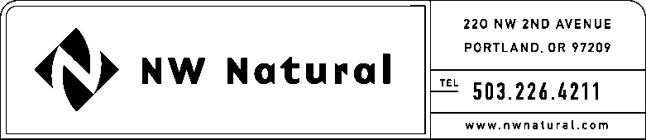

ONITA R. KING
Rates & Regulation
Tel: 503.721.2452
Fax: 503.721.2516
Email: ork@nwnatural.com

April 30, 2015

VIA ELECTRONIC FILING

Steven V. King, Executive Director and Secretary
WASHINGTON UTILITIES &
TRANSPORTATION COMMISSION
1300 S Evergreen Park Drive, SW

Post Office Box 47250
Olympia, Washington 98504-7250

Re: Request for Extended Effective Date
UG-150409 / NWN WUTC Advice No. 15-02 – General Rule 3: Deposits

Northwest Natural Gas Company, dba NW Natural (“NW Natural” or the “Company”), respectfully request that the effective date of the above-referenced advice filing be extended to May 29, 2015. Following discussions with Staff it was determined that additional review time is needed.

Please address correspondence on this matter to me with copies to the following:

eFiling

Rates & Regulatory Affairs
NW Natural
220 NW Second Avenue

Portland, Oregon 97209
Telecopier: (503) 721-2516
Telephone: (503) 226-4211, x3589
eFiling@nwnatural.com

Sincerely,

NW NATURAL

/s/ Onita King

Onita R. King
Rates and Regulation

