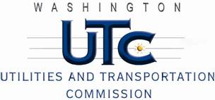

Memorandum

June 15, 2012

To: TR-112049 - File

From: Kathy Hunter, Deputy Assistant Director Transportation Safety

Subject: TR-112049 Washington and Idaho Railway (WIR)

Grade Crossing Protective Fund (GCPF) project to upgrade the crossing surface at the Bishop Boulevard crossing in Pullman

On December 29, 2011, the Washington Utilities and Transportation Commission (Commission) awarded WIR a GCPF grant totaling $8,740.30 to upgrade the crossing surface of the Bishop Boulevard highway rail-grade crossing. The crossing is located in the City of Pullman and the USDOT number assigned to this crossing is 066274K.

On March 26, 2012, WIR requested an extension of time until May 31, 2012, to complete the project. On March 29, 2012, the Commission issued Order 02 approving the request for an extension of time until July 1, 2012.

On June 14, 2012, the applicant, WIR submitted a request for reimbursement pursuant to Commission orders. Along with the reimbursement, WIR submitted photographs of the new crossing surface which verifies that the project was completed according to the specifications outlined in the orders approving the grant.

Please close this docket.

Attachment