January 29, 2016

Mr. Steven King

Executive Director and Secretary

Washington Utilities and Transportation Commission

1300 South Evergreen Park Drive SW

Olympia WA 98504-7250

**RE: Lifeline ETCs Annual Filings to the Federal Communications Commission pursuant to**

**47 C.F.R. §54.416(b); Docket UT-160028**

Dear Mr. King:

Attached please find a copy of the Annual Lifeline Eligible Telecommunications Carrier Certification Form (FCC Form 555) for Ellensburg Telephone Company d/b/a FairPoint Communications, which was filed with the Universal Service Administrative Company as well as with the Federal Communications Commission.

Please contact Beth Westman at 207.535.4249 or bwestman@fairpoint.com with any questions or concerns regarding this filing.

Sincerely,

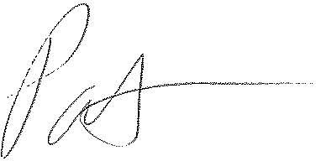

Patrick L. Morse

Senior VP Governmental Affairs

FairPoint Communications

P: 620-227-4409

F: 620-227-8576