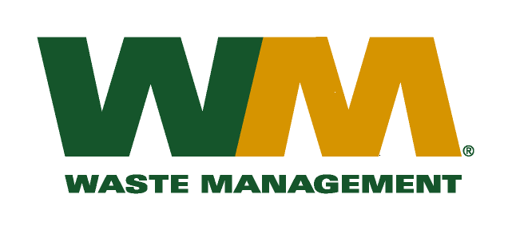

October 2, 2009

Washington Utilities and Transportation Commission

Chandler Plaza Building

1300 S. Evergreen Park Drive SW

P.O. Box 47250

Olympia, WA. 98504-7250

Dear Sirs:

Subject: Waste Management - Northwest, a division of Waste Management of Washington, Inc.(G-237); Tariff # 17

Please find enclosed revised tariff pages 2 and 6 for the above-referenced company. The purpose of these tariff page revisions is to reflect the new garbage utility tax adopted by the City of Lynnwood. Pursuant to Ordinance No. 2746, Chapter 3.41.030 of the Lynnwood Municipal Code was amended to reflect a new utility tax of 6% on the total gross revenues earned from businesses engaged in garbage collection within the City limits to be effective on January 1, 2010. The effective tax rate to be billed to our customers will be 6.38%. The proposed effective date of these tariff revisions will be January 1, 2010.

Enclosed for your review is a copy of City of Lynnwood Ordinance No. 2746. Customers will be notified of this new fee on their next regularly scheduled billing after the approval by the Commission.

If you have any questions or need additional information, please contact me at (425) 814-7840.

Very truly yours,

Michael A. Weinstein

Senior Pricing Manager, Pacific Northwest Market Area

cc: Tim Crosby

City of Lynnwood