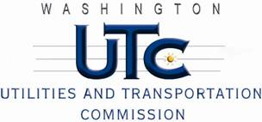

Memorandum
December 18, 2009

To: TR-091493 - File

From: Kathy Hunter, Deputy Assistant Director Transportation Safety

Subject: TR-091493 Columbia Basin Railroad
Grade Crossing Protective Fund (GCPF) Project at Stratford Road in the City of Moses Lake, Washington

On September 23, 2009, the Washington Utilities and Transportation Commission (Commission) awarded a GCPF grant totaling $6,732 for replacing incandescent lights with LEDs at the Stratford Road crossing in the City of Moses Lake. The USDOT number assigned to this crossing is 396986W.

On December 17, 2009, the applicant, Columbia Basin Railroad submitted a request for reimbursement in the amount of $6,084.97 pursuant to Commission order. On December 4, 2009, Commission staff conducted a site visit and verified that the project is completed according to the specifications outlined in the order approving the grant.

Please close this docket.

