June 17, 2015

Mr. Steven King

Executive Director and Secretary

Washington Utilities and Transportation Commission

1300 South Evergreen Park Drive SW

Olympia WA 98504-7250

**RE: 2015 CAF-ICC Data Collection Filed with USAC and the FCC** for Ellensburg Telephone Company d/b/a FairPoint Communications

Dear Secretary:

Pursuant to section 54.304(d)(1) of the FCC’s rules, enclosed please find copies of the 2015 CAF-ICC Data Collection showing projected eligibility for CAF-ICC funding that NECA has submitted to the FCC and USAC on behalf of Ellensburg Telephone Company d/b/a FairPoint Communications.

This information is being filed as CONFIDENTIAL pursuant to WAC 480-07-160. Ellensburg Telephone Company d/b/a FairPoint Communications believes that public availability of this information could cause potential, but irreparable, injury to the company because of the nature of this information. The submitted data includes specific proprietary information about the company's access traffic and associated revenues. This information on the "demand" for switched access services - i.e., the number of units sold of specific categories of rate elements - is not made publicly available by the company at the level of disaggregation presented; nor is comparable information on other providers' access services made publicly available by those providers. The demand represents an aggregation of telecommunications traffic delivered by the company to, or delivered to the company by, numerous individual carriers, no one of which would be able to determine the totals from its own internal data relating to traffic exchanged with the company. Even if the total demand were known, however - or could be estimated based on market surveys or publicly available data - it would not reveal the detailed breakdown of demand among the various rate elements that are included in the attachment.

Please contact Beth Westman at 207.535.4249 or bwestman@fairpoint.com with any questions or concerns regarding this filing.

Sincerely,

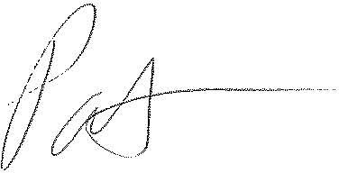

Patrick L. Morse

Senior VP Governmental Affairs

FairPoint Communications

P: 620-227-4409

F: 620-227-8576