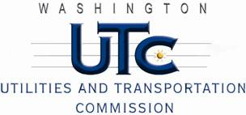

Memorandum

June 20, 2013

To: TR-121379 - File

From: Betty Young, Compliance Investigator, Transportation Safety

Subject: TR-121379 – Puget Sound & Pacific Railroad

Grade Crossing Protective Fund (GCPF) project to modify a railroad-highway grade crossing at Provost Road in Silverdale, USDOT #101947R

On August 31, 2012, the Washington Utilities and Transportation Commission (Commission) awarded the Puget Sound & Pacific Railroad (PSAP) a GCPF grant in the amount of $20,000 to modify and improve active warning devices at the Provost Road crossing near Silverdale. The USDOT is #101947R. The estimated project cost was $27,196.30 with PSAP paying for all costs exceeding that amount. The final cost of the project, $17,493.37, was less than the approved grant amount.

On June 6, 2013, PSAP submitted a request for reimbursement for work pursuant to Commission order. Because the commission does not currently have its own signal inspector, Jerome Polk, a certified FRA signal inspector, conducted a site visit on June 19, 2013, and verified that the project was completed according to the specifications outlined in the order approving the grant.

Please close this docket.