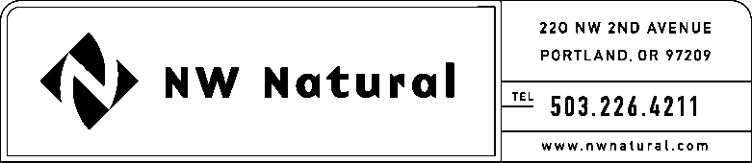

# GAIL A. HAMMER

Tariff and Regulatory Compliance

Tel: 503.226.4211, ext. 5865

Fax: 503.721.2516

email: gail.hammer@nwnatural.com

September 17, 2015 NWN Advice No. WUTC 15-05A / UG-151785

**DO NOT REDOCKET**

***VIA ELECTRONIC FILING***

Steven King, Executive Director and Secretary

Washington Utilities and Transportation Commission

1300 S. Evergreen Park Drive, S.W.

P.O. Box 47250

Olympia, Washington 98504-7250

**RE:** **Docket UG-151785; DO NOT REDOCKET. Supplemental Filing:**

**Schedule G, Energy Efficiency Services and Programs – Residential and Commercial**

Northwest Natural Gas, dba NW Natural (“NW Natural” or the “Company”) files herewith the following revision to its Tariff WN U-6, stated to become effective with service on and after **October 1, 2015**:

Eleventh Revision of Sheet G.1,

Schedule G,

“Energy Efficiency Services and Programs – Residential and Commercial.”

The Company’s Energy Efficiency Plan (“Plan”) proposed in the filing NWN Advice No. WUTC 15-05 dated August 31, 2015 does not change.

The purpose of this filing is to correct the revision number on Sheet G.1 to remove reference to pages G.2 through G.6 as they were cancelled on a previous filing.

The Company respectfully requests that the tariff sheet filed herein be approved to become effective with service on and after October 1, 2015.

As requested by WAC 480-80-103(4)(a), I certify that I have authority to issue tariff revisions on behalf of NW Natural.

A copy of the filing is available for public inspection in the Company’s main office in Portland, Oregon and on its website at [www.nwnatural.com](http://www.nwnatural.com).

Please address correspondence on this matter to me with copies to the following:

eFiling

NW Natural Rates & Regulatory Affairs

220 NW Second Avenue

Portland, Oregon 97209

Telecopier: (503) 721-2516

eFiling@nwnatural.com

If you have any questions, please contact me at 1-503-226-4211, extension 5865.

Sincerely,

NW NATURAL

*/s/ Gail A. Hammer*

Gail A. Hammer

Rates & Regulatory Affairs

Attachment