February 24, 2015

Mr. Steven King

Executive Director and Secretary

Washington Utilities and Transportation Commission

1300 South Evergreen Park Drive SW

Olympia WA 98504-7250

**RE: 2015 Connect America Fund, WC Docket No 10-90 –**

**Ellensburg Telephone Company d/b/a FairPoint Communications**

Dear Mr. King:

The Federal Communications Commission requires that CAF Phase I, Round 2 recipients file by February 24, 2014 certain information identifying the specific locations to be counted toward satisfaction of the associated deployment obligation for the receipt of the CAF funds.

The enclosed spreadsheets satisfy that obligation by identifying in CSV format the 4,851 locations to which FairPoint intends to deploy qualifying broadband, by census block “FIPS” code, NECA “OCN” company code, Study Area Code (“SAC”), wire center “CLLI” code, and latitude and longitude

coordinates.

Please contact Beth Westman at 207.535.4249 or bwestman@fairpoint.com with any questions or concerns regarding this filing.

Sincerely,

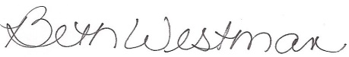

Beth Westman

State Government Affairs Manager

FairPoint Communications