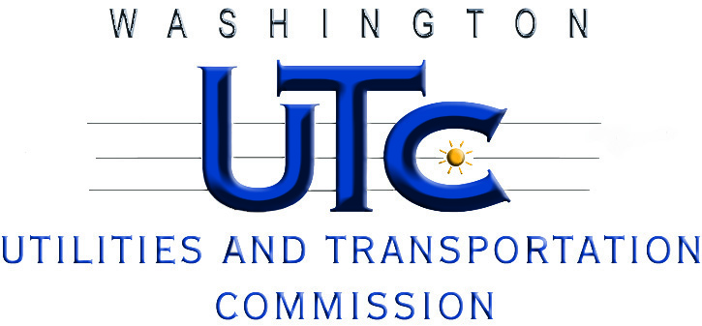

**A G E N D A**

**March 29, 2012**

**Rulemaking Workshop - Docket UE-112133**

**Review of Standards in WAC 480-108**

**for Interconnection with Electric Generators**

1. Welcome and Introductions 1:30 pm
2. Suggested Changes due to Advances in Technology

or Operational Experience with Current Rules 1:45 pm

* Requirements under industry standards (UL 1741 and

IEEE 1547) for disconnect switches, trip transfer and relays

* Insurance requirements

1. Interconnection Application Processes 2:15 pm

* Multi-tiered process
* Standard forms and technical screens
* Standard fees and charges
* Dispute Resolution

(We will take a 10 to 15 minute break at about 3:00 pm.)

1. WAPUDA, AWC, WRECA Process Proposal 3:30 pm
2. Next Steps – Closing 4:00 pm