June 20, 2014

Steven V. King, Executive Director and Secretary
Utilities and Transportation Commission
1300 S. Evergreen Park Dr. SW
P.O. Box 47250
Olympia, WA 98504-7250

RE: Washington Utilities and Transportation Commission v. Interstate Telecommunications, Inc.

Commission Staff’s Response to Application for Mitigation of Penalties UT-140894

Dear Mr. King:

On May 30, 2014, the Utilities and Transportation Commission issued a $1,000 Penalty Assessment in Docket UT-140894 against Interstate Telecommunications, Inc. for 10 violations of Washington Administrative Code (WAC) 480-120-382, which requires telecommunications companies to furnish annual reports to the commission no later than May 1 each year.¹

On June 4, 2014, Interstate Telecommunications, Inc. wrote the commission requesting mitigation of penalties (Mitigation Request).² In its Mitigation Request, Interstate Telecommunications, Inc. does not dispute that the violation occurred. The company states, “We mailed our report on April 28th or 29th, 2014. During the week of May 5th we received our letter back from the US Postal Service marked undeliverable. No stamp in terms of missing postage, incorrect address. We then sent the report back to by federal express with a note of apology. Though probably immaterial, I believe our history will show us with constant and timely reports.”

It is the company’s responsibility to ensure that the regulatory fee is paid and the annual report is filed by the May 1 deadline. On February 28, 2014, Annual Report packets were mailed to all regulated telecommunication companies. The instructions for annual report completion page of
the annual report informed the regulated company that it must complete the annual report form, pay the regulatory fees, and return the materials by May 1, 2014, to avoid enforcement action.

UTC Annual Reports
June 16, 2014
Page 2

On May 19, 2014, Interstate Telecommunications, Inc. filed its annual report with no regulatory fees due. The company has been active since June 8, 1994. No prior violations of WAC 480-120-382 are on commission record. Staff supports the company’s request for mitigation as this is the first delinquent annual report filing. Staff recommends a reduced penalty assessment of $200.

If you have any questions regarding this recommendation, please contact Amy Andrews, Regulatory Analyst, at (360) 664-1157, or aandrews@utc.wa.gov.

Sincerely,

Sondra Walsh, Director
Administrative Services

ATTACHMENT A
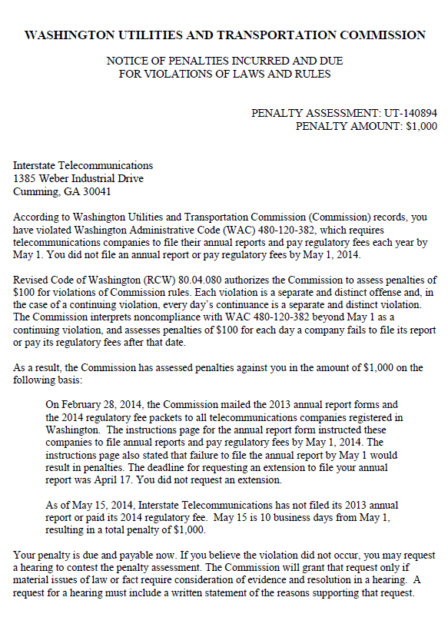

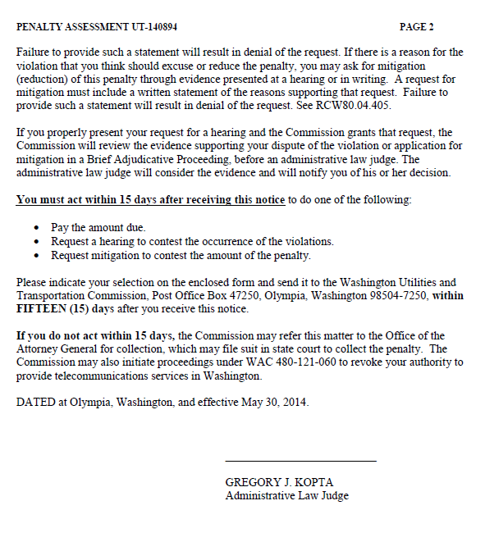

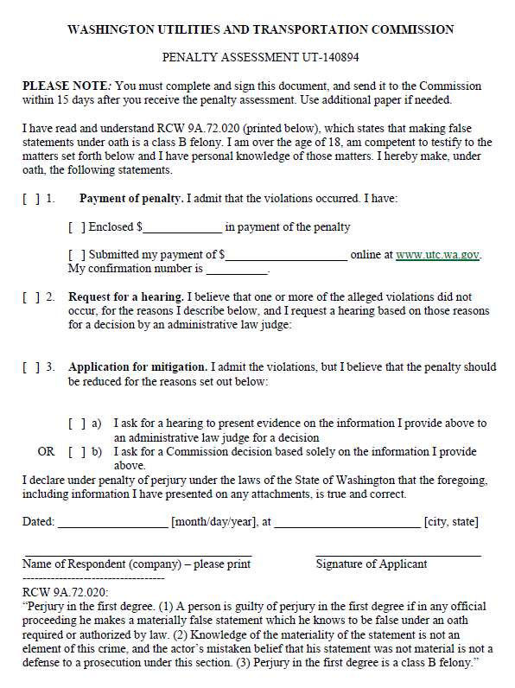

ATTACHMENT B
