Powell says duration of low interest rates ‘will be measured in years’

PUBLISHED FRI, SEP 4 20203:52 PM EDT
Jeff Cox
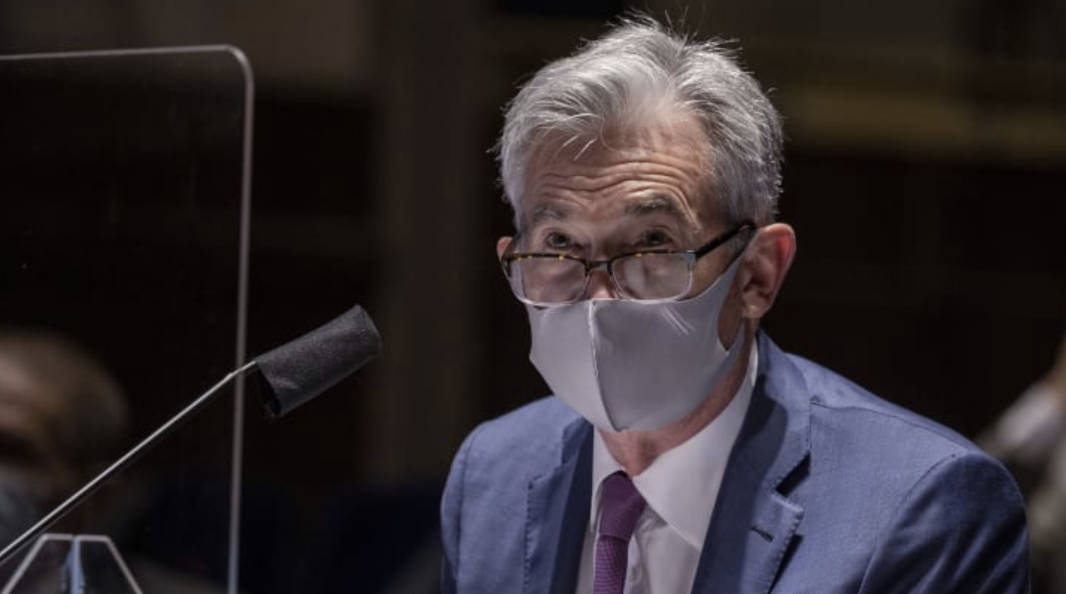

Federal Reserve Chairman Jerome Powell, wearing a face mask, testifies before the House of Representatives Financial Services Committee during a hearing on oversight of the Treasury Department and Federal Reserve response to the outbreak of the coronavirus disease (COVID-19), on Capitol Hill in Washington, U.S., June 30, 2020.

Interest rates are likely to stay low for years as the economy fights its way back from the coronavirus pandemic, Federal Reserve Chairman Jerome Powell said in remarks published Friday afternoon.

“We think that the economy’s going to need low interest rates, which support economic activity, for an extended period of time,” Powell told NPR in an interview after the nonfarm payrolls report was released earlier in the day. “It will be measured in years.”

The statement aligns with comments from Powell and other Fed officials over the past week or so.

In a major change to its approach to monetary policy, the central bank now has set a stated directive that inflation will be allowed to float above the Fed’s 2% target for a period time after running below, as has been the case for most of the past decade.

The move effectively means that the Fed no longer will hike rates in order to head off inflation that historically had come with lower unemployment rates.

Powell called the Friday jobs repot “a good one.” Nonfarm payrolls rose by 1.37 million and the unemployment rate slid to 8.4%, still higher than anything since the early days of the financial crisis recovery but a good deal better than the pandemic peak of 14.7%.

Powell again tied the progress of the economy to the coronavirus, and he encouraged following safety guidelines like wearing masks and maintaining social distancing.

“There’s actually enormous economic gains to be had nationwide from people wearing masks and keeping their distance,” he said.

