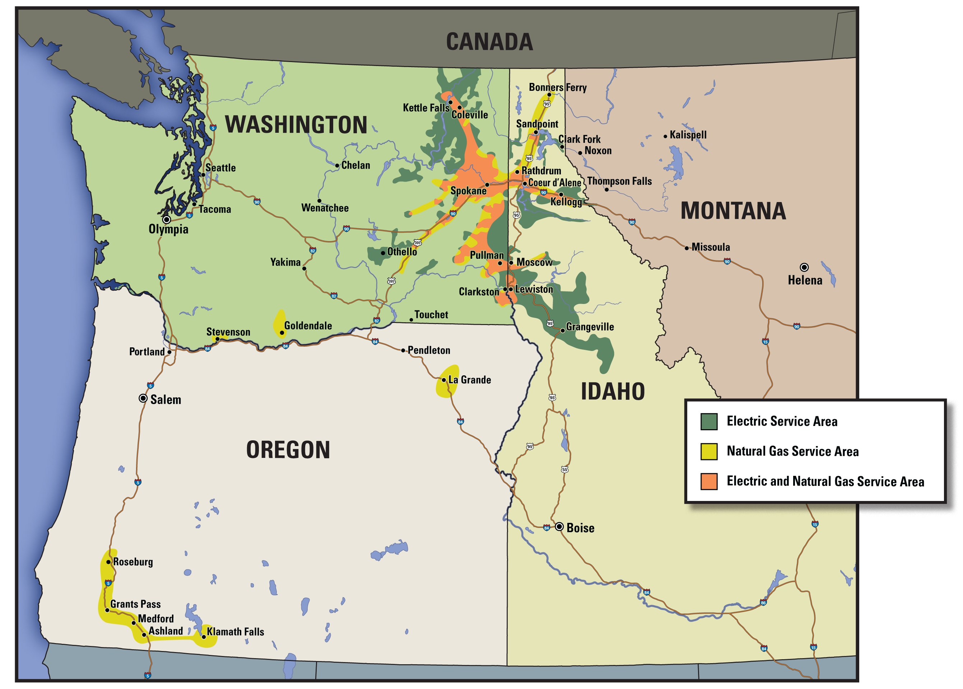
Avista’s Electric and Natural Gas Service Areas

