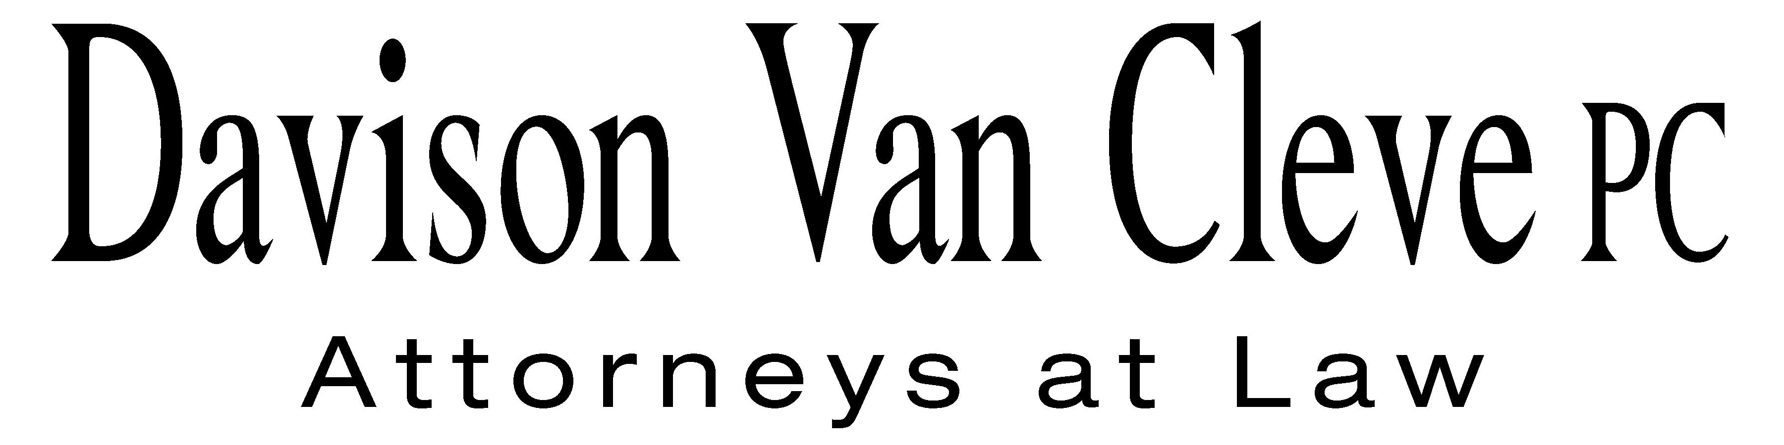  
TEL (503) 241-7242 ● FAX (503) 241-8160 ● jec@dvclaw.com  
Suite 400  
333 SW Taylor  
Portland, OR 97204

March 30, 2015

***Via Electronic Mail and Federal Express***

Chairman Dave Danner

Commissioner Philip Jones

Commissioner Ann Rendahl

Washington Utilities and Transportation Commission

PO Box 47250

1300 S. Evergreen Park Drive, SW

Olympia, WA 98504-7250

Re: Washington Utilities and Transportation Commission v. Puget Sound Energy, Dockets UE-130617, *et al.*

Dear Commissioners:

The Industrial Customers of Northwest Utilities (“ICNU”) was asked by Commission Staff (“Staff”) to state ICNU’s intention, concerning the filing of testimony or the offering of witnesses in opposition to the settlement agreement filed by PSE, Staff, and Public Counsel on March 27, 2015, regarding proposed changes to Puget Sound Energy’s Power Cost Adjustment mechanism. Per Staff’s request, ICNU clarifies that it does not intend to file testimony or offer witnesses, or make any additional filings beyond the settlement opposition letter to the Commissioners, filed by ICNU on March 27, 2015.

Sincerely yours,

*/s/ Jesse E. Cowell*

Jesse E. Cowell

cc: Sheree Strom Carson

Sally Brown

Simon ffitch