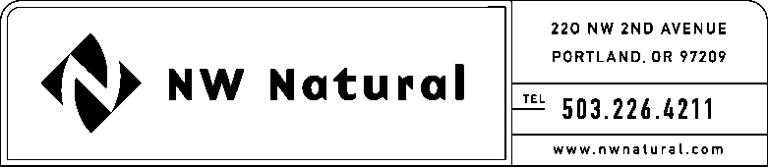

# **ONITA R. KING**

Rates & Regulation

Tel: 503.721.2452

Fax: 503.721.2516

email: ork@nwnatural.com

May 29, 2015 NWN WUTC Advice No. 15-03

***VIA ELECTRONIC FILING***

Steven V. King, Executive Director and Secretary

WASHINGTON UTILITIES &

TRANSPORTATION COMMISSION

1300 S Evergreen Park Drive, SW

### Post Office Box 47250

Olympia, Washington 98504-7250

**Re: Schedule A: City of Vancouver Tax Surcharge**

**WUTC Docket No. UG-141135**

Northwest Natural Gas Company, dba NW Natural (“NW Natural” or “Company”), files herewith the following revisions to its Tariff WN-U-6, stated to become effective on and after June 29, 2015:

Sixth Revision of Sheet A.2,

Schedule A,

“Addition of City Exactions (continued).”

The purpose of this filing is to request that the Commission approve an extension of the City of Vancouver exaction tax adjustment to September 30, 2015. The reason for the extended date is to allow for the full collection of the tax exaction assessment made by the City of Vancouver (“City”) associated with an audit conducted by the City in 2013.

In Docket UG-141135, the Commission approved revisions to Schedule A of the Company’s Tariff to allow for the collection of a tax exaction adjustment of 2.499% to be effective July 1, 2014 through June 30, 2015. The Company currently projects that there will be about $64,000 that will be under collected if the surcharge ends June 30. It is the Company’s belief that the reason for the under collection is a direct result of the warmer than average weather experienced during the 2014-2015 winter period.

In order to ensure that the full amount is collected from customers, NW Natural requests that the Commission extend the termination date of this tax adjustment to September 30, 2015. The table below depicts the Company’s current projections for the collection of the $64,000:

|  |  |  |
| --- | --- | --- |
| **Projection Month** | **Estimated Collection** | **Balance** |
| June | $30,000 | $64,000 |
| July | $28,000 | $36,000 |
| August | $25,000 | $11,000 |
| September | $25,000 | ($14,000) |

Based on the table above, it is projected that the collection will reverse itself sometime in September. As a result, the Company will continue to closely monitor the collection activity for this account. Should we find that the anticipated collection in any month between June and September will bring the balance close to or at zero, the Company will immediately discontinue billing the 2.499% adjustment. The Company is of the understanding that a tariff revision would not be required in order to terminate the adjustment on or before September 30.

The Company requests that the tariff sheets filed herewith be permitted to become effective with service on and after June 29, 2015.

As required by WAC 480-80-103(4)(a), I certify that I have authority to issue tariff revisions on behalf of NW Natural.

Copies of this letter and the filing made herewith are available in the Company's main office in Oregon and on its website at [www.nwnatural.com](http://www.nwnatural.com).

Please address correspondence on this matter to me with copies to the following:

eFiling

Rates & Regulatory Affairs

NW Natural

220 NW Second Avenue

### Portland, Oregon 97209

Telecopier: (503) 721-2516

Telephone: (503) 226-4211, x3589

eFiling@nwnatural.com

Sincerely,

NW NATURAL

*/s/ Onita King*

Onita R. King

Rates and Regulation

attachments