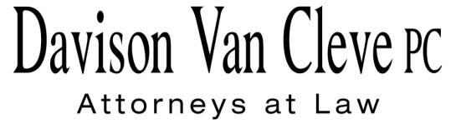

TEL (503) 241-7242 ● FAX (503) 241-8160 ● tcp@dvclaw.com

Suite 400

333 S.W. Taylor

Portland, OR 97204

October 7, 2015

### Via E-mail and Federal Express

Mr. Steven V. King

Executive Director & Secretary

Washington Utilities & Transportation Commission

1300 S. Evergreen Pk. Dr. S.W.

P. O. Box 47250

Olympia, WA 98504-7250

Re: Washington Utilities and Transportation Commission v.

Pacific Power & Light Company

**Docket UE-144160**

Dear Mr. King:

This letter is to inform the Washington Utilities and Transportation Commission and parties to the above-referenced docket that, after reviewing the opening briefs filed by the other parties, Boise White Paper, L.L.C. does not intend to file a reply brief in this matter.

Thank you for your assistance. If you have any questions, please do not hesitate to contact me.

Sincerely,

*/s/ Tyler C. Pepple*

Tyler C. Pepple

cc: Service List

##### CERTIFICATE OF SERVICE

I hereby certify that I have this day served the attached Letter upon all parties in this proceeding, as shown below, by sending a copy via electronic mail.

DATED this 7th day of October, 2015.

Davison Van Cleve, P.C.

*/s/ Tyler C. Pepple*

Tyler C. Pepple

|  |  |  |  |  |  |  |  |  |
| --- | --- | --- | --- | --- | --- | --- | --- | --- |
| |  |  | | --- | --- | | **BRYCE DALLEY**  Pacific Power & Light Co.  825 NE Multnomah STE 2000  Portland, OR 97232  bryce.dalley@pacificorp.com  washingtondockets@pacificorp.com | **DUSTIN TILL**  Pacific Power & Light Co.  825 NE Multnomah St. STE 1800  Portland, OR 97232  Dustin.Till@pacificorp.com | | **JOHN LOWE**  Renewable Energy Coalition  12050 SW Tremont Street  Portland, OR 97225  jravenesanmarcos@yahoo.com  **IRION SANGER**  Sanger Law, P.C.  1117 SE 53rd Avenue  Portland, OR 97215  irion@sanger-law.com | **CHRISTOPHER M. CASEY**  Washington Utilities & Transportation Commission  Assistant Attorney General  1400 S. Evergreen Park Drive SW  PO Box 40128  Olympia, WA 98504-7250  ccasey@utc.wa.gov | |  |  | |  |  | |
|  |