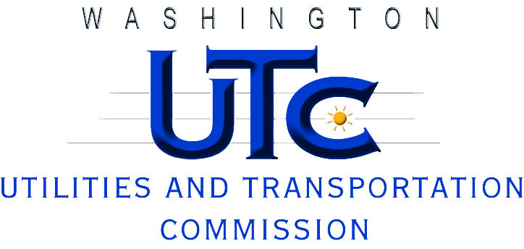

Investigation Report

Puget Sound Energy

U-100182

Rayne Pearson  
Compliance Investigations

September 2010