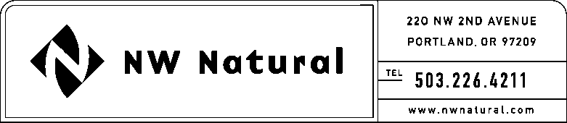

# MARK R. THOMPSON

Manager, Rates and Regulatory Affairs

Tel: 503.721.2476

Fax: 503.721.2516

email: mark.thompson@nwnatural.com

September 9, 2015

Steven V. King, Executive Director and Secretary

WASHINGTON UTILITIES &

TRANSPORTATION COMMISSION

1300 S Evergreen Park Drive, SW

### Post Office Box 47250

Olympia, Washington 98504-7250

**Re: Docket UG-110199 – 2nd 2015 Semi-Annual Report on Environmental Costs**

Northwest Natural Gas Company, dba NW Natural (“NW Natural” or the “Company”), hereby files its second 2015 semi-annual report of environmental costs deferred, in compliance with condition (3)(i) of Order No. 01 in Docket UG-110199.

**Background**

On January 26, 2011, NW Natural filed with the Washington Utilities and Transportation Commission (“Commission”) a petition requesting authorization to defer expenses associated with environmental remediation at the following five Company-owned sites: Gasco, Central Gas Holding, Tar Deposit, Portland Harbor, and Wacker (aka Siltronic).

NW Natural’s predecessor, Portland Gas and Coke Company, produced and sold manufactured gas to Oregon and Washington customers from 1913 to 1956. The Company is now incurring costs related to the investigation and remediation of environmental contamination resulting on properties where gas was either manufactured onsite or nearby, or where there were activities associated with manufactured gas.

Starting in early 2006, NW Natural pursued recovery of insurance for its environmental liabilities from insurance policies that it believed would cover such liabilities. That litigation was concluded through various settlements, which NW Natural disclosed in an 8-K, and which was attached to its 1st 2014 Semi-Annual report filed in the subject docket. With these settlements, the Company received a total of approximately $150.5 million in insurance receipts.

In the Company’s 2011 General Rate Case filed with the Public Utility Commission of Oregon (“OPUC”) on December 31, 2011 and docketed as UG-221, NW Natural requested OPUC approval to begin collecting from customers the environmental remediation costs that it has been deferring in Oregon since 2003. In its request, the Company asserted that 96.68% of the costs were attributable to providing service to Oregon customers and explained its expectation that 3.32% are associated with serving Washington customers. Work papers were filed demonstrating how historic sales data were used to determine this allocation. In that rate case, the OPUC approved a mechanism for recovery of our deferred environmental expenses, but ordered a new proceeding, to determine specific parameters about how this mechanism will operate. One of the open issues in that case was the allocation of expenses between Oregon and Washington.

On February 20, 2015, the OPUC issued an order in that separate proceeding that it opened to determine details relating to NW Natural’s cost recovery mechanism. In that order, among other things, the Commission approved the allocation to Oregon of 96.68% of the remediation costs related to sites that were used to serve both Washington and Oregon customers historically.

Through a previous supplemental petition for an accounting order filed July 17, 2012, in UG-110199, the Company proposed to the Washington Commission an allocation of 3.32% deferred costs to service in Washington. That petition was not acted upon, and NW Natural was informed by Staff that the Commission would not want to entertain this request until the Company actually sought rate recovery in Washington. The Company currently anticipates that it will still request an allocation to Washington customers of 3.32% of its deferred expenses, and the same allocation of insurance proceeds to Washington customers. The table below shows 3.32% of total costs incurred during the timeframe February 1, 2011 through June 30, 2015, for environmental remediation at the following sites: Gasco, Central Gas Holding, Tar Deposit, Portland Harbor, and Wacker (aka Siltronic).

In accordance with Order No. 1 in the subject docket, interest is not being accrued to the deferred balances. However, as stated in the Order, these costs may be eligible for working capital treatment when the Company files its next rate case.



Please note, as stated above, insurance receipts received to date, and allocable to Washington under NW Natural’s proposed allocation more than offset these deferred amounts.

If you have any immediate questions, please call me direct at (503) 721-2476.

Sincerely,

*/s/ Mark R. Thompson*

Mark R. Thompson

Manager, Rates and Regulatory Affairs