®WASHINGTON WATER SERVICE COMPANY
August 28, 2015

Radiance Homes, LLC PO Box 1996
Gig Harbor, WA 98335-3996

RE: Cedar Crest Water System, DOH ID# l l 887T, Water Main Extension, Plat of Forest Lawn, Parcel
#022107-2018, Pierce County Dear Owner:
This extension agreement is between Washington Water Service Company (the "Washington Water") and Radiance Homes, LLC (the "Owner") to construct water main line extension and to provide water utility service to parcel(s) #022107-2017. This extension agreement sets forth the terms and conditions as well as the estimated costs of the water main line extension and service connections to the Cedar Crest water system. The actual costs of the engineering, materials and labor to complete this project may vary from the estimated costs provided in this agreement. The final cost amount will be billed based on actual hours and materials used to complete the project.

Attached to this extension agreement is Exhibit A, the legal description of the parcels/property for which water service is requested for a total of 8 connections.

Estimated costs are based on water lines being installed prior to other utilities in the road easement outside of the paved area and sidewalks. Washington Water shall not be responsible for any additional costs incurred by Owner or Washington Water due to obtaining necessary permits, approvals, completion of construction or any other foreseen or unforeseen delays.

This estimated cost includes the cost of engineering, materials, and labor only, unless specifically listed on the attached Exhibit B, Cost Estimate. Upon execution of this extension agreement and prior to commencement of construction or issuance of a Preliminary Certificate of Water Availability, Washington Water requires a deposit payment of fifty-percent (50%) of the estimated construction costs for the labor and materials to construct the onsite water distribution system. Per Exhibit B, the estimated cost for construction is $ 15,007.00 (plus W.S.S.T. of $ 1,185.55) for a total estimated construction cost of $16,192.55, for a deposit due of $ 8,096.28 payable to Washington Water Service Company.

All past due accounts will be charged 1.5% per month ( 18% per annum). The estimate costs as set forth in this extension agreement are subject to change after thirty (30) days of the first above written date.
Terms and conditions of this Agreement are subject to the review and approval of the Washington State Utilities and Transportation Commission (the "Commission"). Once this extension agreement is executed, Washington Water will submit the extension agreement, if applicable to the Commission for their approval. Upon the Commission's approval, plans will be prepared, and if required, submitted to the Washington State Department of Health for their approval. Once all necessary approvals have been obtained and the required deposit received, Washington Water will schedule and cause construction to commence.

The final cost amount due will be billed based on actual hours, materials used, and non construction costs including engineering reports and other construction documents. The total cost could vary from the amount estimated, due to unforeseen issues that could arise during the installation of the distribution system that are beyond the control of Washington Water. The total cost of all listed work including construction and engineering for this project is estimated at $ 18,450.00 (See Exhibit B).

Radiance Homes, LLC
Line Extension Agreement - Plat of Forest Lawn Page 2 of 2

Owner is to provide Washington Water with a 5-foot utility easement at all property comers on approved development plans. Once all construction has been completed, certification of completion signed by an engineer and all approvals received, Owner will provide Washington Water with a Bill of Sale (attached as Exhibit C), which will transfer the ownership of these contributed facilities to Washington Water Service Company.

Hookup fees for each dwelling unit as listed in Washington Water's approved tariff will be in addition to this Agreement and must be paid prior to installation of individual meters.

A Final Certificate of Water Availability will NOT be issued for the final plat or for building permits, until payment in full has been received. Once a Certificate of Water Availability has been issued and the final plat has been approved by Pierce County, all lots are subject to a "Ready to Serve Charge" as listed in the most recently approved tariff on file with the Washington Utilities and Transportation Commission.

Neither this Agreement nor any of the rights, interests or obligations under this Agreement may be assigned or delegated, in whole or in part, by operation of law, or otherwise, by Owner without the prior written consent of Washington Water, and any such assignment without such prior written consent shall be null and void. Nothing expressed or referred to in this Agreement will be construed to give any person other than the parties to this Agreement any legal or equitable right, remedy, or claim under or with respect to this Agreement or any provision of this Agreement. This Agreement and all of its provisions and conditions are for the sole and exclusive benefit of the parties to this Agreement and their successors and assigns.

If these terms and condition are acceptable, please sign below and send this original extension agreement back to our office. Ifyou have any questions, please give me a call directly in Gig Harbor at (253) 851-4060 or toll free at (877) 408-4060.
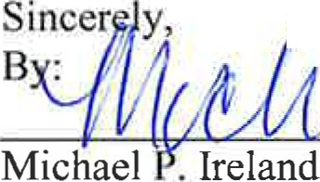1 dt UV Accepted
By
President Print Name:

Phone:

Date Accepted:

Enclosure(s)
cc: Gordon Ballantyne (gordon@structureenterprise.com) Charlene Pratt, Accounting Manager
Matt Brown, Engineering Manager Sue Hull, Customer Service Manager File: Cedar Crest Water System

W:\Systems\Cedar Crest !DI 1887T Pierce\Projects - Work Orders\Forest Lawn\Contract\Cedar Crest-Forest Lawn_Line Extension Agreement.doc

RADIANCE HOMES LLC
PO BOX 1996
GIG HARBOR, WA 98335
07-13 2132
19-57/1250
57145

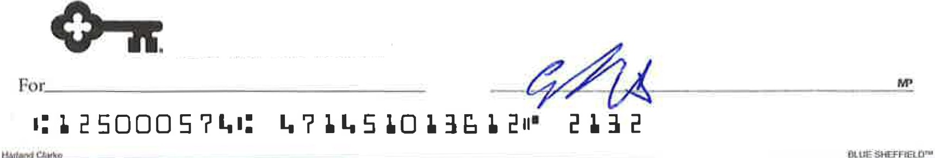

KeyBank Na!lonal Association Gig Harbor,WA 98335
- 1-888-KEY481Z- Key.corrf

Exhibit A
Legal Description

Parcel Summary for 0221072018

P,op:erty D<Stllirs Parcel Number: Site Address: Account Type: Category:
Use Code:
APll:([iliSar'Q'et..ilS

0221072016
7320 46TH AV NW
Real Property
Land and Improvements
9100-VACANT LANO UNDEVELOPED
-Y:a'!Cj1llVCr [)eta,ils Taxpayer Name: Hailing Address:

Assessm.e,1t Iifetails

RADIANCE HOMES LLC PO BOX 1996
GIG HARBOR WA 98335-3996

Value Are11: Appr Acct Type: Business N11me:
Last nspection:
R'tSlatedl,P'llrr«els
Pll
Residential

01/22/2014 - Physical nspection
2015 Values for 2016 Tax
Taxable V11lue: 116,100
Assessed Value: 115,100

Group Account Number: n/a
Mobile/MFG Home and PerS-Onal Property n/a parcel(s) located on this parcel:
Real parcel on which this porcel is located: n/a
Tax Description
Section 07 Township 21 Range 02 Quarter 24 :NE OF SE OF SE OF NW EXC E 30 FT FOR RD EASE OF RECORD SEG E 9616

Iacknowledge and agree to the prohibitions listed in RCW 42.5fi.070(9) against releasing and/or using li.sts of individuBl5 for commerdill purposes. Neither Pierce
County nor tfie Assessor-Treasurer warnnts the accuracy, reliability or timeliness of any information in this system, and shall not be neld liable for losses caused by using tliis information. Portions or this infonn11tlon may not btt current or accurate. Any person or entity who relies on any fnformation e>bhined from this system does so at their own risk. All
critical information should be intlepenrl•ntly verified.

Exhibit B
Cost Estimate

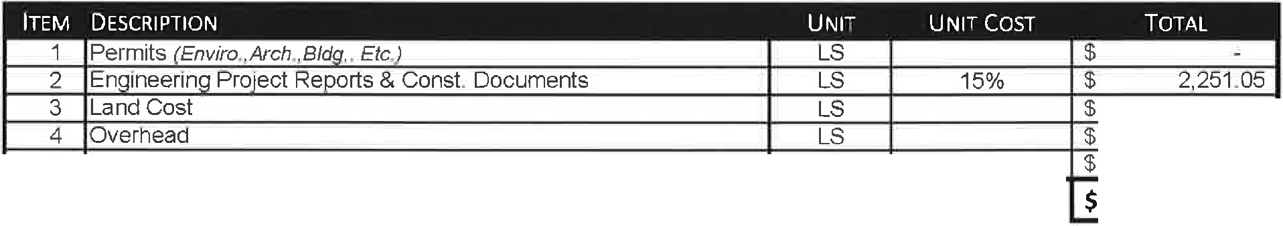WASHINGTON WATER SERVICE COMPANY
14519 Peacock Hill Ave NW • PO Box 336 • Gig Harbor, WA 98335
Phone: (253) 851-4060 • Toll Free: (877) 408-4060 • Fax: (253) 857-4001

FOREST LANE Water Main Line Extension (NO FIRE FLOW)
Cedar Crest, 10#114887 T, Pierce County
DATE: August 28, 2015

CONSTRUCTION COSTS

2
3
4
5
6
7
8 Water Main - 2 1/2"

- Sin le Service on 2-Y:,"
- Double Service on 2-Y:z''
- Blow Off
- lntertie to Existin Mains 16
17
18
19
20
21

NON CONSTRUCTION COSTS
$
$
$
$
$
$
$
$
$
$ | 8,160.00
$
$ | 928.00
$
$ | 786.00
$ | 1,551 00
$ | 1JOO 00
$ | 1 882.00
$
$
$
$
$
$
$ | 15, .00
$ | 1,185.55
$ | 16,192.55

$
$
$
$
$
480 LF $ 17.00
$
EA $ 928 00
$
3 EA $ 262.00
3 EA $ 517.00
2 EA $ 850.00
EA $ 1 882.00
$
$
$
$
$
$
Subtotal Construction Costs*
Sales Tax {7.90%)
TOTAL Construction Costs

5 Bondin Based on Construction Costs LN* 0%
TOTAL NON Construction Costs 2,251.05
TOTAL Construction & Non Construction Costs l $ 18,443.60 I $ 18,443.70 I
(l\ctuaO (Rounded Up Value)

NON HARD COSTS
TOTAL ESTIMATED PROJECT COST1I $ 18,450.00 I

Cost per Lot: Assumptions:
$18,450

- This document is intended to forecast approximate construction costs based upon current information and similar projects. and is not intended to accurately represent actual design or construction components or prices The final project costs will be billed based on actual hours and materials used to complete the project
- Totals are rounded to nearest $1,000 .
- Costs in this estimate are good for 30-days from the date the estimate is issued.
- A deposit maybe required to be paid prior to commencement of construction .

Exhibit C
Example Bill of Sale

After recording return to: Washington Water Service Company PO Box 336
Gig Harbor, WA 98335

BILL OF SALE

KNOW ALL MEN BY THESE PRESENTS, that . a Washington Corporation, for and in consideration of good wi ll, do hereby grant, bargain, and convey unto Washington Water Service Company, a Washington corporation, the following described extension to serve lots within the plat of Forest Lawn, serviced by the Cedar Crest water system, Washington State Department of Health ID # J J 887T. County of Pierce, State of Washington, to-wit:

All appurtenances for this extension within to include, but not limited to, pipeline, hydrants, services, etc.; are included in this Bill of Sale.

EXECUTED at , Washington this day of , 2015.

By _ Owner's Name

STATE OF WASHINGTON

SS
County of _ )

On this day Personally appeared before me , to me known to me to be the __
& of that executed the within and forgoing instrument, and acknowledged said instrument to be the free and voluntary act and deed of said [individual] [corporation], for the uses and purposes therein mentioned, and on oath stated that he was authorized to execute said instrument.

WITNESS MY HAND and official seal this day of , 2012

NOTARY PUBLIC in and for the state of Washington residing at

My appointment expires: _

\\hbrsvr\Washington Water Service\Systems\Cedar Crest ID/ / 887T Pierce\Projects - Work Orders\Forest Lawn\Contract\Cedar Crest-Forest Lawn_Line Extension Agreement.doc

