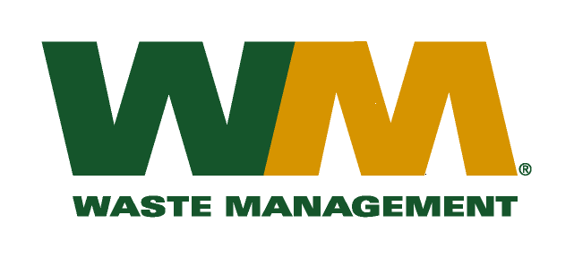

Washington Utilities and Transportation Commission

Chandler Plaza Building

1300 S. Evergreen Park Drive SW

P.O. Box 47250

Olympia, WA. 98504-7250

Subject: Waste Management of Skagit County, a division of Waste Management of Washington, Inc.(G-237); Tariff # 17

Dear Sirs:

Enclosed herein, please find revised pages 2 and 31 to the above-referenced tariff. These proposed revised tariff pages contain new Item 230 disposal rates for loose and hard to handle waste delivered to the Island County Solid Waste Disposal Facilities. The Island County Commissioners approved these disposal fees as reflected in Exhibit A to Island County Resolution C-124-09. The effective date of these disposal fees were on January 1, 2010. The effective date of the proposed tariff revisions is January 15, 2011.

Also enclosed for your review is Exhibit A to Island County Resolution C-124-09 and document from Island County that defines the criteria for these new disposal rates. Upon approval by the Commission, affected customers will be notified of these new disposal rates on their next regularly scheduled billing. If you have any questions or need additional information, please contact me at (425) 814-7840.

Very truly yours,

Michael A. Weinstein

Senior Pricing Manager, Pacific Northwest Market Area

cc: Elena Araujo

Tim Crosby

Joe Krukowski

Clerk of the Board, Island County Chair