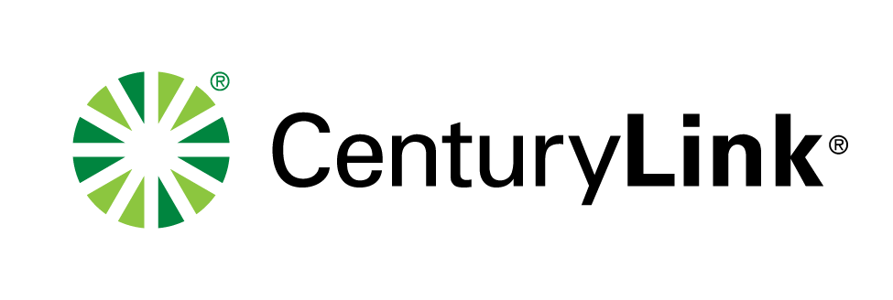

March 1, 2017

Mr. Steven King

Executive Director and Secretary

1300 S. Evergreen Park Dr. S.W.

P.O. Box 47250

Olympia, Washington 98504-7250

RE: Advice No. WA17-02A for United Telephone Company of the Northwest d/b/a CenturyLink

Dear Mr. King:

Attached for filing are revised sheets of Access Service Tariff WN U-11 for United Telephone Company of the Northwest d/b/a CenturyLink. The revised sheets are:

**ACCESS SERVICE TARIFF**

**WN U-11**

|  |  |  |
| --- | --- | --- |
| **SECTION** | **SHEET** | **REVISION** |
| 2 | 26 | 1st |
| 2 | 28 | 2nd |
| 2 | 29 | 1st |

This filing proposes to revise the late payment penalty to $0.000407 per day to gain Company-wide standardization within interstate and intrastate access tariffs, where possible. The deposit interest rate language was revised to reference the late payment penalty for the interest rate paid on deposits. Customers were notified of this change.

The proposed effective date is April 1, 2017.

If you have questions concerning this filing, you may contact me at the phone number or email address listed below or Phil Grate at (206) 345-6224.

Sincerely,

Debra Levy

Manager Regulatory Operations

Enclosures

ec: Phil Grate, CenturyLink

John Felz, CenturyLink

**DEBRA LEVY**

Debra.Levy@CenturyLink.com

600 New Century Parkway

New Century, KS 66031

Voice: (913) 353-7088

WA17-02A