Agenda Date: October 27, 2011

Item Numbers: B2 and B3

**Dockets: TG-111672 and TG-111674**

Company Names: Murrey’s Disposal Company, Inc., G-9

American Disposal Company, Inc., G-98

Staff: Dave Gomez, Deputy Assistant Director

**Recommendation**

Staff recommends the commission issue a complaint and order suspending revisions to each company’s tariffs, and allowing monthly recyclable commodity revenue adjustments filed by each company on September 15, 2011, and revenue sharing to become effective on November 1, 2011, on a temporary basis, subject to refund.

**Discussion**

On September 15, 2011, American Disposal Company, Inc., and Murrey’s Disposal Company, Inc. (American and Murrey’s or the companies), filed with the Washington Utilities and Transportation Commission (commission) revisions to each of its currently effective Tariff No. 25, designated by both companies as Tariff pages 1, 21, 25, 27, 28, 30, 46, 47, 48 and 49. The stated effective date is November 1, 2011.

In their filings, the companies propose to increase the amount they pay to single family and multi-family customers for the value of the recyclable materials that each company collects in their residential recycling collection service. The monthly credit for single family customers would increase from $1.31 to $1.69 and the monthly credit for multi-family customers would increase from $0.67 per yard to $0.76 per yard for each pickup.

Also, on September 15, 2011, both companies filed with the commission a request to retain fifty percent of the revenue they receive from the sale of recyclable materials that they collect in their residential single and multi-family recycling collection service from November 1, 2011, to October 31, 2012.

On September 15, 2011, American and Murrey's filed their joint "2011-12 Company Recycling Plan: Pierce County Single-Stream Recycling Program, Updated September 2011" with the commission. Included with the plan was a summary of the results achieved from the previous 2010-2011 plan year. In addition, as required in Order 01, TG-101545 and Order 01, TG-101548, both companies also filed the amount of money they retained and the amount of money they spent during the 2010-2011 plan year. Table 1 below shows that the companies spent $469,204 of the $974,336 retained from customers, leaving $505,131 unspent and kept by the companies.

Table , 2010-2011 Recyclable Commodity Revenue Retained vs. Revenue Spent

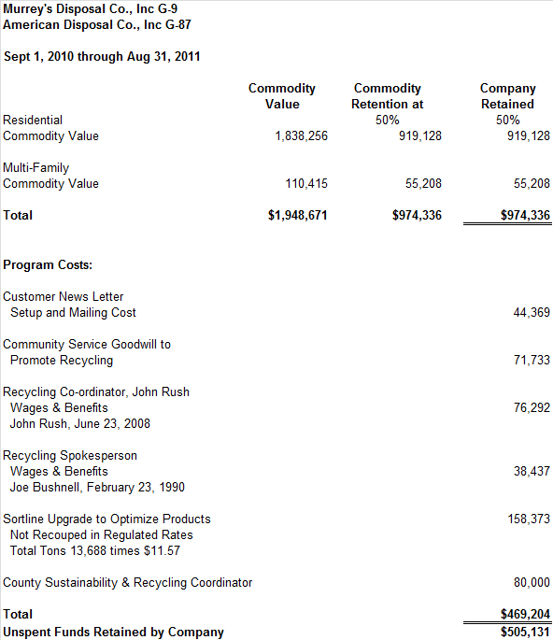

On September 16, 2011, Pierce County (county) filed a letter with the commission signed by Stephen C. Wamback, Solid Waste Administrator, Pierce County Department of Public Works and Utilities. The letter confirms that the companies' performance in the past year had achieved the goals and objectives specified in the 2010-2011 plan and that the county recommends to the commission that the companies should keep the fifty percent of recyclable commodity revenues they retained (summarized in Table 1 above).

Both companies have participated in recyclable commodity revenue sharing since 2005. In 2010, the Legislature increased the maximum revenue sharing amount from thirty percent to fifty percent. In the 2010-2011 plan period, the commission first authorized the companies to retain fifty percent of the recyclable commodity revenue. Table 2 below shows year by year results for revenue sharing activities for both companies.

Table , American and Murrey’s Plan Year Results

|  |  |  |  |  |  |  |  |
| --- | --- | --- | --- | --- | --- | --- | --- |
| **Year** | **Revenue** | **Returned to Customers** | **Retention Percent** | **Retained by Company** | **Spent on Plan Activities** | **Net Retention** | **Net Retention Percent** |
| 2005-2006 | $1,467,003 | $1,040,677 | 30% | $426,327 |  |  |  |
| 2006-2007 | $2,056,916 | $1,439,841 | 30% | $617,075 |  |  |  |
| 2007-2008 | $2,699,701 | $1,889,791 | 30% | $809,910 |  |  |  |
| 2008-2009 | $1,323,903 | $926,732 | 30% | $397,171 |  |  |  |
| 2009-2010 | $1,626,537 | $1,138,576 | 30% | $487,961 | $408,277 | $79,684 | 16% |
| 2010-2011 | $1,948,671 | $974,336 | 50% | $974,336 | $469,204 | $505,131 | 52% |

The 2009-2010 plan period was the first year that the commission required the companies to report, at the end of the plan period, the amount of revenue they retained, the amount of money they spent on the activities identified in their recycling plan, and the effect the activities had on increasing recycling.

RCW 81.77.185 states that the commission shall allow a solid waste collection company collecting recyclable materials from residential single and multi-family customers to retain "up to fifty percent of the revenue paid" to the company for the material if the company submits a plan to the commission that is certified by the appropriate local government authority as being consistent with the local government solid waste plan and that demonstrates how the revenues will be used to increase recycling. The remaining revenue must be passed through to residential single and multi-family customers.

The "2011-12 Company Recycling Plan: Pierce County Single-Stream Recycling Program, Updated September 2011" sets forth specific actions that both companies will take to increase recycling using recyclable commodity revenues retained. The plan calls for fifty percent of the retained recyclable commodity revenue to be awarded to the companies on the basis of:

* Ongoing implementation of the single-stream recycling program - up to 5 percent awarded;
* Meeting or exceeding data monitoring and reporting requirements - up to 4 percent awarded;
* Achieving and demonstrating a recycling increase and disposal decrease per household pounds per month compared to 2004 and 2009 baselines - up to 21 percent awarded;
* Providing the county with direct financial support for county-wide recycling programs and overall sustainability initiatives - up to 16 percent awarded; and
* Achieving additional goals as agreed upon by the county and the companies in 2011 and 2012 - up to 25 percent awarded. [1]

Included in the letter dated September 16, 2011, from the county is the certification required by RCW 81.77.185 that the plan submitted by the companies on September 15, 2011, for the upcoming year (2011 to 2012) is consistent with the local government solid waste management plan and that the new plan demonstrates how the revenues will be used to increase recycling. Therefore, the county recommends the commission allow American and Murrey’s to retain fifty percent of the actual value of recyclable commodity revenues received during the period of this agreement (November 1, 2011, through October 31, 2012).

WAC 480-70-351 (1) provides, "[T]he commission encourages solid waste collection companies to develop programs intended to increase recycling. The commission will, among other things, consider whether a proposed program:

* Provides an incentive to the party who controls the actions or behaviors that the program intends to change;
* Defines measurable outcomes reasonably attributable to the proposed program; and
* May have any unintended results or consequences.”

Staff notes that the companies did not spend $505,131 of the retained revenue. Retained revenue is defined as a percentage (fifty percent in this case) of total revenue. Because total revenue increases or decreases with the change of tons collected and prices paid, the amount of retained revenue will also change. The potential for even greater amounts of unspent retained revenue exits if tons or prices increase. This issue is demonstrated in Docket TG-111681, a recyclable commodity revenue sharing filing by Mason County Garbage Company, Inc., that reported unspent retained revenue of $30,012, adjusted by a performance penalty for of $8,491 leaving a net retained revenue amount of $21,521, or 25 percent of retained revenue in the case of Mason County Garbage Company, Inc. Staff believes that the amount of unspent revenue is an unintended result or consequence of the Company’s 2010-2011 plan and is otherwise contrary to the public interest. Further, Staff contends that there are no changes or safeguards in the proposed 2011-2012 plan that would prevent even greater unspent revenues. Consistent with WAC 480-70-351, the Commission should consider whether the proposed 2011-2012 plan may, likewise, have any unintended results or consequences.

American and Murrey’s have not yet demonstrated the proposed revenue sharing is fair, just, reasonable and sufficient and, as a result, might injuriously affect the rights and interests of the public. Staff therefore recommends that the commission issue a complaint and order suspending revisions to American's and Murrey’s Tariffs (each No. 25), and allowing monthly recyclable commodity revenue adjustments filed on September 15, 2011, and revenue sharing on a temporary basis, subject to refund.

**Conclusion**

Issue a complaint and order suspending revisions to American's and Murrey’s Tariff No. 25, and allowing monthly recyclable commodity revenue adjustments filed on September 15, 2011, and revenue sharing to become effective on November 1, 2011, on a temporary basis, subject to refund.

1. While the total for each of these bullets exceeds fifty percent, the plan does not authorize the Company to retain any more than fifty-percent as authorized by law. The additional percentages reflect a menu of deliverables available to the Company to meet the objectives of the plan and earn the full fifty percent retention.