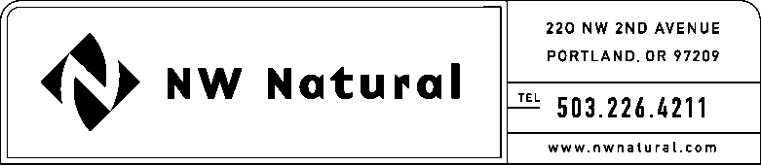

# **ONITA R. KING**

Rates & Regulation

Tel: 503.721.2452

Fax: 503.721.2516

email: ork@nwnatural.com

May 13, 2015 NWN WUTC Advice No. 15-02A

REPLACEMENT FILING

**DO NOT REDOCKET**

***VIA ELECTRONIC FILING***

Steven V. King, Executive Director and Secretary

WASHINGTON UTILITIES &

TRANSPORTATION COMMISSION

1300 S Evergreen Park Drive, SW

### Post Office Box 47250

Olympia, Washington 98504-7250

**Re: Docket No. UG-150409; REPLACEMENT FILING DO NOT REDOCKET**

**General Rule 3: Deposits**

Northwest Natural Gas Company, dba NW Natural (“NW Natural” or “Company”), files herewith the following replacement sheets reflecting revisions and additions to its Tariff WN-U-6, stated to become effective on and after May 29, 2015:

Sixth Revision of Sheet iii,

Tariff Index;

First Revision of Sheet 3.1,

General Rules and Regulations (continued),

“Rule 3 Deposits;”

Second Revision of Sheet 3.2,

General Rules and Regulations (continued),

“Rule 3 Deposits;” and

Original Sheet 3.3,

General Rules and Regulations (continued),

“Rule 3 Deposits.”

The purpose of this filing is to reflect changes to the above-referenced sheet that are made pursuant to discussions between the Company and Commission Staff.

The Company requests that the tariff sheets filed herewith be permitted to become effective with service on and after May 29, 2015.

As required by WAC 480-80-103(4)(a), I certify that I have authority to issue tariff revisions on behalf of NW Natural.

Copies of this letter and the filing made herewith are available in the Company's main office in Oregon and on its website at [www.nwnatural.com](http://www.nwnatural.com).

Please address correspondence on this matter to me with copies to the following:

eFiling

Rates & Regulatory Affairs

NW Natural

220 NW Second Avenue

### Portland, Oregon 97209

Telecopier: (503) 721-2516

Telephone: (503) 226-4211, x3589

eFiling@nwnatural.com

Sincerely,

NW NATURAL

*/s/ Onita King*

Onita R. King

Rates and Regulation

attachments