June 30, 2014

Steven V. King, Executive Director and Secretary
Utilities and Transportation Commission
1300 S. Evergreen Park Dr. SW
P.O. Box 47250
Olympia, WA 98504-7250

RE: Washington Utilities and Transportation Commission v. Telenational Communications, Inc.

Commission Staff’s Response to Application for Mitigation of Penalties UT-140921

Dear Mr. King:

On June 2, 2014, the Utilities and Transportation Commission issued a $1,000 Penalty Assessment in Docket UT-140921 against Telenational Communications, Inc. for 10 violations of Washington Administrative Code (WAC) 480-120-382, which requires telecommunications companies to furnish annual reports to the commission no later than May 1 each year.¹

On June 16, 2014, Telenational Communications, Inc. wrote the commission requesting mitigation of penalties (Mitigation Request).² In its Mitigation Request Telenational Communications, Inc. does not dispute that the violation occurred. The company states, “This is the first time I’ve filed our annual report and didn’t realize the org. filing was incomplete until I rec’d this letter. I’m including the confirmation from the filing on 5/2/14.”

It is the company’s responsibility to ensure that the regulatory fee is paid and the annual report is filed by the May 1 deadline. On February 28, 2014, Annual Report packets were mailed to all regulated telecommunication companies. The instructions for annual report completion page of
the annual report informed the regulated company that it must complete the annual report form, pay the regulatory fees, and return the materials by May 1, 2014, to avoid enforcement action.

On May 5, 2014, Telenational Communications, Inc. was contacted by commission staff via email notifying the company of the incomplete status of the report.³ The email communication
UTC Annual Reports
June 30, 2014
Page 2

was sent to the address provided by the company on the cover page of its 2013 Telecommunications Annual Report.⁴ The email contained specific technical assistance as to the
data required to consider the report complete. Telenational Communications, Inc. did not respond to the email request.

On June 12, 2014, Telenational Communications, Inc. filed its complete annual report with no regulatory fees due. The company has been active since November 8, 1995. The company was previously delinquent in filing the 2009 and 2011 reports. Staff does not support the company’s request for mitigation due to recent prior violations of WAC 480-120-382 and lack of response to the incomplete report notification.

If you have any questions regarding this recommendation, please contact Amy Andrews, Regulatory Analyst, at (360) 664-1157, or aandrews@utc.wa.gov.

Sincerely,

Sondra Walsh, Director
Administrative Services

ATTACHMENT A
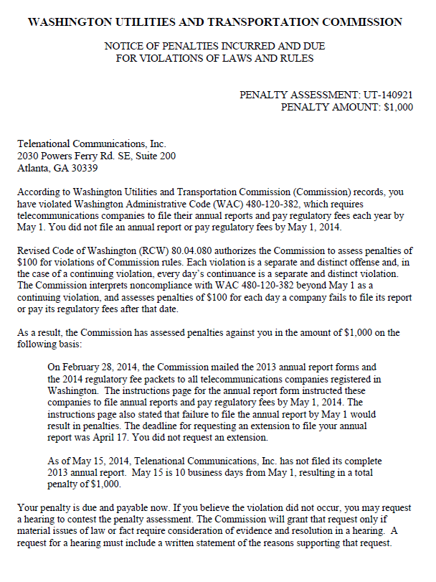

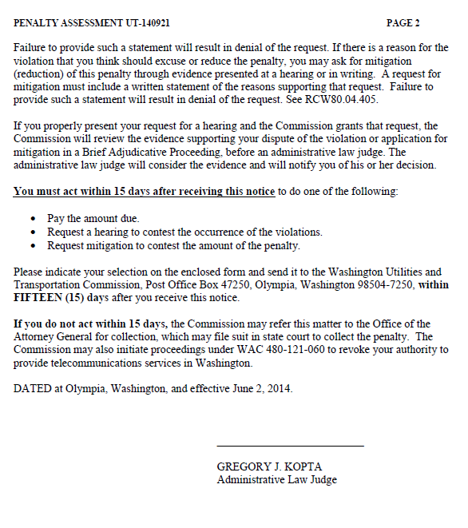

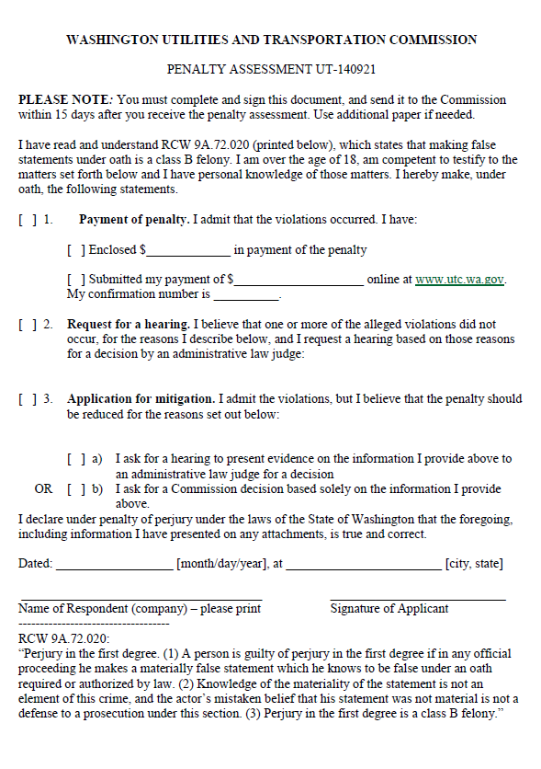

ATTACHMENT B
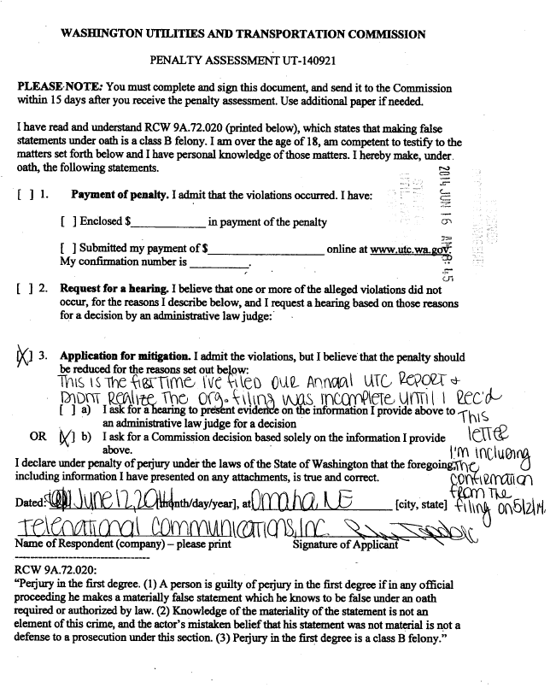

ATTACHMENT C
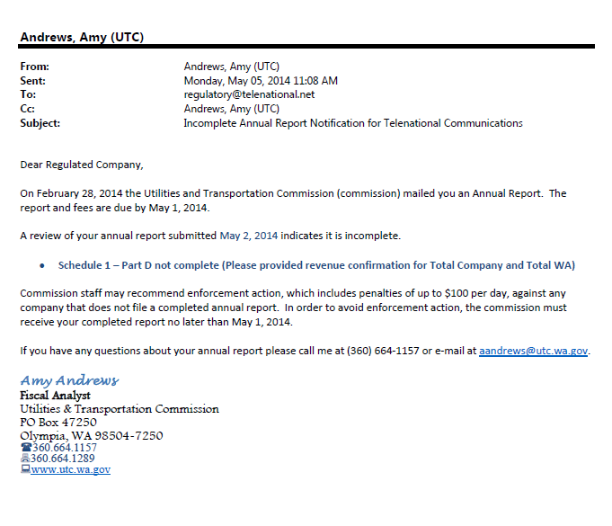

ATTACHMENT D
