Christopher T. Wall
Direct: (253) 620-6522
E-mail: cwall@gth-law.com
June 8, 2015
VIA EMAIL and U.S. MAIL
records@utc.wa.gov

Washington Utilities and
Transportation Commission
1300 S. Evergreen Park Drive S.W.
P.O. Box 47250
Olympia, WA 98504-7250

RE: Five Star Moving & Storage, LLC
Docket No. TV-150223
Dear Sir or Madam:
Enclosed for filing in the above-referenced docket are the original and three copies of Five Stars Moving & Storage LLC’s Response in Opposition to UTC Staff’s Motion to Strike, and Certificate of Service.

Sincerely,
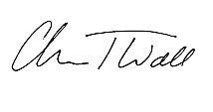
Christopher T. Wall

CTW:bf

