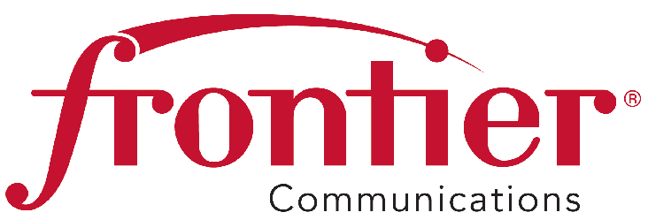

**Frontier Communications Northwest Inc.**

1800 – 41st Street

Suite N-100

Everett, WA 98203

Fax: 425-261-5262

September 3, 2015

Advice No. 3351

Mr. Steven King, Executive Director and Secretary

Washington Utilities and Transportation Commission

P.O. Box 47250

1300 S. Evergreen Park Drive SW

Olympia, WA 98504-7250

Dear Mr. King:

Frontier Communications Northwest Inc. (“Frontier”) submits Advice No. 3351, a tariff filing in the General and Local Exchange Tariff, WN U-17, Section 1 and 4.

The purpose of this filing is to correct an oversight in tariff revision filings made in Advice No. 3338 on August 8, 2013 and Advice No. 3339 on August 12, 2013 and subsequent filings on August 28, 2013 that were replacement filings to correct errors in the earlier filings.

Background

On January 24, 2013, Frontier filed with the Commission a Replacement Amended Petition for Approval of Minimal Regulation in Accordance with RCW 80.36.320 (Petition), seeking classification as a competitive telecommunications company throughout its current service territory. The Commission suspended the filing and set the matter for hearing.

On May 22, 2013, Frontier, Staff and Public Counsel (“Settling Parties”) filed a settlement agreement resolving the disputed issues between them (Staff/PC Settlement). These parties filed a Joint Narrative and testimony in support of their agreement on May 23, 2013. Included in this settlement agreement was “Appendix A” which consisted of a marked up tariff which struck those services which the Settling Parties agreed would be deleted from the tariff and moved to a service catalog. The Staff/PC Settlement included a provision that basic residential and small business services remain tariffed.

On July 22, 2013, the Commission entered Order 06, Final Order Approving Settlement Agreements with Conditions and Classifying Services as Competitive. The Commission approved the Staff/PC Settlement with a modifying condition that the basic residential and small business services also be removed from the tariff and moved to the exchange services catalog.



September 3, 2015

Page 2

Compliance tariff filings made on August 8, 2013 (Advice Filing No. 3338), August 12, 2013 (Advice Filing No. 3339) and the August 28, 2013 correction filing included removal of the basic residential access line service and basic single line business service but overlooked and failed to include removal of four associated basic local services: Anonymous Call Block, *69, Call Block and Call Trace.

On September 13, 2013 the Commission issued an Order Approving Compliance Filings. (Order 9)

Request

Frontier submits this Advice No. 3351, a tariff filing in the General and Local Exchange Tariff, WN U-17, Section 1 and 4, to correct its compliance filings made in Advice Filings 3338 and Advice 3339 to remove Anonymous Call Block, *69, Call Block and Call Trace from the tariff and move these services to Frontier’s exchange services catalog. These are not stand-alone services.  They are optional add-on features (or services) that supplement basic access line service and could not be purchased by themselves.

Frontier requests an effective date of October 9, 2015 for this tariff filing.

Pursuant to WAC 80-80-103(4) and WAC 480-80-104(8), I certify that I am authorized to make this filing on behalf of the company. If you have any questions regarding this filing, please contact Cathy Dahlquist at (360) 367-9144.

Sincerely,

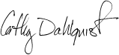

Cathy Dahlquist

Manager, Government & External Affairs

Enclosures

W.U.T.C.

September 3, 2015

Advice No. 3351

Attachment A

# General and Local Exchange Tariff, WN U-17

Section 1

1st Revised Table of Contents Sheet 1

1st Revised Table of Contents Sheet 3

Section 4

1st Revised Table of Contents Sheet 1

1st Revised Sheet 1

1st Revised Sheet 2

1st Revised Sheet 3

1st Revised Sheet 4

1st Revised Sheet 5

**FRONTIER COMMUNICATIONS NORTHWEST INC.**

**EVERETT, WASHINGTON**

**N O T I C E**

Frontier Communications Northwest Inc. (“Frontier”) submits Advice No. 3351, a tariff filing in the General and Local Exchange Tariff, WN U-17, Section 1 and 4.

The purpose of this filing is to correct an oversight in tariff revision filings made in Advice No. 3338 on August 8, 2013 and Advice No. 3339 on August 12, 2013 and subsequent filings on August 28, 2013 that were replacement filings to correct errors in the earlier filings.

The effective date for this tariff filing is October 9, 2015.

A copy of this tariff is available for public inspection at the following Frontier Plus store locations:

1402 SE Everett Mall Way 18700 33rd Ave. West, Suite D 4916 W. Clearwater

Everett Lynnwood Kennewick

Everett Frontier Plus Alderwood Frontier Plus Kennewick Frontier Plus

Posted at __________________________

__________________________

by __________________________

Post in above store location.