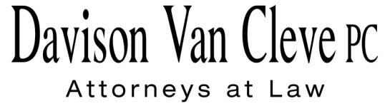

TEL (503) 241-7242 ● FAX (503) 241-8160 ● mail@dvclaw.com

Suite 400

333 S.W. Taylor

Portland, OR 97204

August 12, 2013

***Via Electronic Mail and Federal Express***

Mr. Steven V. King

Washington Utilities and Transportation Commission

1300 S. Evergreen Park Dr. S.W.

P.O. Box 47250

Olympia, WA 98504-7250

Re: In the matter of WUTC v. PacifiCorp.

**Docket No. UE-130043**

Dear Mr. King:

Enclosed for filing in the above-referenced docket, please find the Confidentiality Agreement signature page for Jesse E. Cowell.

If you have any questions, please do not hesitate to call.

Sincerely yours,

*/s/ Karen A. Zolka*

Karen A. Zolka

Enclosure

cc: Service List

**CERTIFICATE OF SERVICE**

I HEREBY CERTIFY that I have this day served the foregoing documents upon all parties of record in this proceeding, as shown below, by causing the same to be sent via electronic mail.

Dated at Portland, Oregon, this 12th day of August, 2013.

­*/s/ Karen A. Zolka*

Karen A. Zolka

|  |  |
| --- | --- |
| **THE ENERGY PROJECT**  The Energy Project  3406 Redwood Ave.  Bellingham, WA 98225 | **SARAH WALLACE**  SENIOR COUNSEL PACIFICORP  825 NE MULTNOMAH, SUITE 1800  PORTLAND OR 97232  sarah.wallace@pacificorp.com |
| **McDowell, Katherine**  McDowell Rackner & Gibson PC  419 SW 11th Avenue STE 400  Portland, OR 97205  katherine@mcd-law.com | **ROBERT CEDARBAUM** Assistant Attorney General WUTC PO Box 40128 Olympia, WA 98504-0128 bcedarba@utc.wa.gov |
| **JOSHUA WEBER**  Davison Van Cleve, PC  333 S.W. Taylor STE 400  Portland, OR 97204 | **LISA GAFKEN** Office of the Attorney General 800 Fifth Avenue STE 2000 Seattle, WA 98104-3188 [simonf@atg.wa.gov](mailto:simonf@atg.wa.gov) |
| **MELINDA DAVISON**  Davison Van Cleve, PC  333 S.W. Taylor STE 400  Portland, OR 97204 | **BRAD M. PURDY**  Attorney at Law  2019 N. 17th St.  Boise, ID 83702  bmpurdy@hotmail.com |
| **BOISE WHITE PAPER, L.L.C.** Boise White Paper Holdings, L.L.C. PO Box 50 Boise, ID 83728 |  |