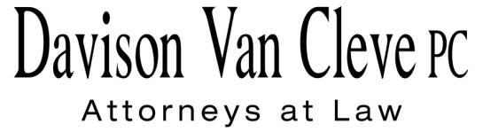

TEL (503) 241-7242 ● FAX (503) 241-8160 ● tcp@dvclaw.com

Suite 400

333 S.W. Taylor

Portland, OR 97204

July 24, 2015

### Via E-mail and Federal Express

Mr. Steven V. King

Executive Director & Secretary

Washington Utilities & Transportation Commission

1300 S. Evergreen Pk. Dr. S.W.

P. O. Box 47250

Olympia, WA 98504-7250

Re: Washington Utilities and Transportation Commission v.

Pacific Power & Light Company

**Docket UE-144160**

Dear Mr. King:

Enclosed for filing in the above-referenced docket, please find an original and one copy of the Cross-Answering Policy Declaration of Bradley G. Mullins on behalf of Boise White Paper, L.L.C.

Thank you for your assistance. If you have any questions, please do not hesitate to contact me.

Sincerely,

*/s/ Tyler C. Pepple*

Tyler C. Pepple

cc: Service List

##### CERTIFICATE OF SERVICE

I certify that I have served the attached Cross-Answering Policy Declaration of Bradley G. Mullins upon all parties in this proceeding, as shown below, by sending a copy via electronic mail and by mailing a copy via First Class U.S. Mail, postage prepaid.

DATED this 24th day of July, 2015.

Davison Van Cleve, P.C.

*/s/ Tyler C. Pepple*

Tyler C. Pepple

|  |  |  |  |  |  |  |  |  |
| --- | --- | --- | --- | --- | --- | --- | --- | --- |
| |  |  | | --- | --- | | **BRYCE DALLEY**  Pacific Power & Light Co.  825 NE Multnomah STE 2000  Portland, OR 97232  bryce.dalley@pacificorp.com | **DUSTIN TILL**  Pacific Power & Light Co.  825 NE Multnomah St. STE 1800  Portland, OR 97232  Dustin.Till@pacificorp.com | | **SALLY BROWN**  Washington Utilities & Transportation Commission  Assistant Attorney General  PO Box 40128  Olympia, WA 98504-0128  sbrown@utc.wa.gov  **JOHN LOWE**  Renewable Energy Coalition  12050 SW Tremont Street  Portland, OR 97225  jravenesanmarcos@yahoo.com | **CHRISTOPHER M. CASEY**  Washington Utilities & Transportation Commission  Assistant Attorney General  1400 S. Evergreen Park Drive SW  PO Box 40128  Olympia, WA 98504-7250  ccasey@utc.wa.gov  **IRION SANGER**  Sanger Law, P.C.  1117 SE 53rd Avenue  Portland, OR 97215  irion@sanger-law.com | |  |  | |  |  | |