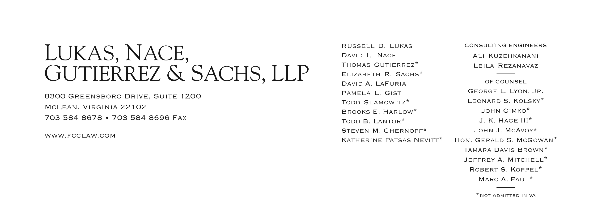

Brooks E. Harlow

(703) 584-8680

bharlow@fcclaw.com

June 29, 2012

**FILED ELECTRONICALLY VIA WEB PORTAL**

**AND HAND DELIVERED VIA COURIER**

Mr. David W. Danner

Executive Director & Secretary

Washington Utilities and Transportation Commission

Post Office Box 47250

1300 S. Evergreen Park Dr. SW

Olympia, Washington 98504-7250

**Subject: UT-111358, United States Cellular Corporation, and**

**Connect America Fund, FCC WC Dkt. No. 10-90,**

**Report for Service Provided in the State of Washington**

Dear Mr. Danner:

Pursuant to FCC requirements as clarified in: *Wireline Competition Bureau Announces Filing Deadline of July 2, 2012, for Eligible Telecommunications Carriers To File Reports Pursuant to Section 54.313(a)(20) Through (a)(6) of the Commission’s Rules*, WC Docket No. 10-90, et al., Public Notice, DA 12-729 (rel. May 8, 2012) (citing 47 C.F.R. § 54.313(i)), we enclose for filing, an informational copy of the filing by U. S. Cellular Corporation ("USCC") in FCC WC Docket No. 10-90 made on June 28, 2012. Pursuant to WAC 480-07-140, we are making this filing electronically and to ensure full compliance with any FCC expectations we are also hand delivering a copy via overnight courier. The FCC filing is confidential. Accordingly, pursuant to WAC 480-07-160, we are filing both a confidential and redacted version.

In the Confidential portion of the filing, each electronic file will contain, as part of the file name, the word "CONFIDENTIAL." Additionally, each page in the Confidential electronic files will be labeled "Confidential Per WAC 480-07-160."

Pursuant to RCW §80.04.095 enclosures designated as "confidential" contain valuable commercial information, including trade secrets and confidential marketing, cost, or financial information, or customer-specific usage and network configuration and design information. Accordingly, pursuant to RCW §80.04.095 such information should not be subject to inspection or copying under RCW Chapter 42.56. Moreover, the records designated as "confidential" contain valuable formulae, designs, and research data, the disclosure of which would produce private gain and public loss and should be exempt from public disclosure pursuant to RCW 42.56.270(1).

In addition to the undersigned, the following might be directly affected by disclosure of the confidential information:

U. S. Cellular Corporation  
 8410 West Bryn Mawr Avenue  
 Chicago, IL 60631  
 Phone: (773) 864-3167  
 E-mail: [John.Gockley@uscellular.com](mailto:Grant.Spellmeyer@uscellular.com)  
 Attention: John C. Gockley

If you have any questions please contact the undersigned.

Very truly yours,  
  
Brooks E. Harlow, P.C.

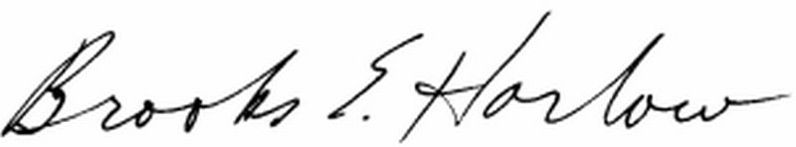

cc: Ms. Jing Liu  
 Ms. Stephanie Cassioppi