September 8, 2016

Mr. Steven King

Executive Director and Secretary

Washington Utilities and Transportation Commission

1300 South Evergreen Park Drive SW

Olympia WA 98504-7250

RE: Form 477 - Docket UT-160032

Dear Mr. King:

Please find the attached Form 477 representing data as of June 30, 2016. YCOM Networks, Inc. d/b/a FairPoint Communications respectfully submits this data under Docket number UT-160032.

Pursuant to WAC 480-07-160, the Company respectfully requests that this filing be treated as confidential and not subject to public inspection. A public, redacted version is included in the filing. This information is not publically available and if subject to public disclosure could cause significant commercial and competitive harm to the Company.

Please contact me at the number below or at pat@fairpoint.com with any questions or concerns regarding this filing.

Sincerely,

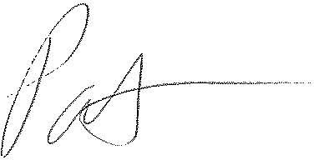

Patrick L. Morse

Senior VP Governmental Affairs

FairPoint Communications

P: 620-227-4409

F: 620-227-8576