**Eligible Telecommunications Carriers’ annual recertification on High Cost Fund pursuant to WAC 480-123-060, 070 and 080**

July 28, 2015

Mr. Steven King, Executive Secretary

Washington Utilities and Transportation Commission

1300 South Evergreen Park Drive SW

Olympia, WA 98504-7250

Re: UT-151346 updating Report 5 Pursuant to WAC 480-123-060 and 47 C.F.R. 54.314

Dear Mr. King:

Pursuant to WAC 480-123-070, The Toledo Telephone Co., Inc. (“Company”) hereby provides and update to Report 5 enclosed with this filing.

Sincerely,

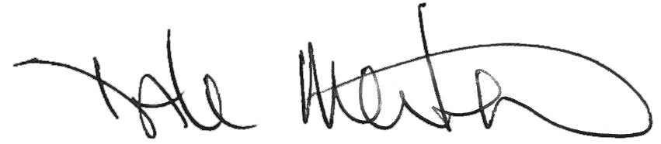

Dale Merten

Chief Operating Officer