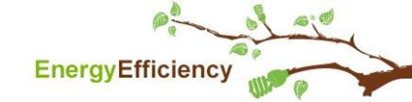

Attachment 1

SBW Consulting Inc.’s

“*Puget Sound Energy 2014-15 Biennial Electric Conservation Achievement Review (BECAR) Final Report”*

*PSE 2014-2015 Biennial Conservation Report*

*June 1, 2016*

