June 20, 2014

Steven V. King, Executive Director and Secretary
Utilities and Transportation Commission
1300 S. Evergreen Park Dr. SW
P.O. Box 47250
Olympia, WA 98504-7250

RE: Washington Utilities and Transportation Commission v. NextNet Telecom, Inc.

Commission Staff’s Response to Application for Mitigation of Penalties UT-140905

Dear Mr. King:

On June 2, 2014, the Utilities and Transportation Commission issued a $1,000 Penalty Assessment in Docket UT-140905 against NextNet Telecom, Inc. for 10 violations of Washington Administrative Code (WAC) 480-120-382, which requires telecommunications companies to furnish annual reports to the commission no later than May 1 each year.¹

On June 9, 2014, Jon Warta wrote the commission on behalf of NextNet Telecom regarding the penalty assessment.² In his letter, Mr. Warta states, “This entity ceased to exist in 2012, and was formally cancelled in 2013. This company has never had any revenue or sold any services. The WUTC was informed in 2012 that this company was not active and no longer intended to operate.” The letter continues, “I am merely providing this as information, since there is no longer an entity called NextNet Telecom in Washington.” Mr. Warta provided an application to withdrawal or dissolve a corporation on a Washington State Department of Revenue form.³

It is the company’s responsibility to ensure that the regulatory fee is paid and the annual report is filed by the May 1 deadline. On February 28, 2014, Annual Report packets were mailed to all regulated telecommunication companies. The instructions for annual report completion page of
the annual report informed the regulated company that it must complete the annual report form, pay the regulatory fees, and return the materials by May 1, 2014, to avoid enforcement action.

UTC Annual Reports
June 20, 2014
Page 2

Commission records reflect no formal request from NextNet Telecom to cancel the registration on file. The letter provided by Mr. Warta will serve as notice to voluntarily cancel the registration of NextNet Telecom as commission records indicate Mr. John Warta as the Chairman, CEO of the company. Staff recommends the penalty be waived and the docket closed.

If you have any questions regarding this recommendation, please contact Amy Andrews, Regulatory Analyst, at (360) 664-1157, or aandrews@utc.wa.gov.

Sincerely,

Sondra Walsh, Director
Administrative Services

ATTACHMENT A
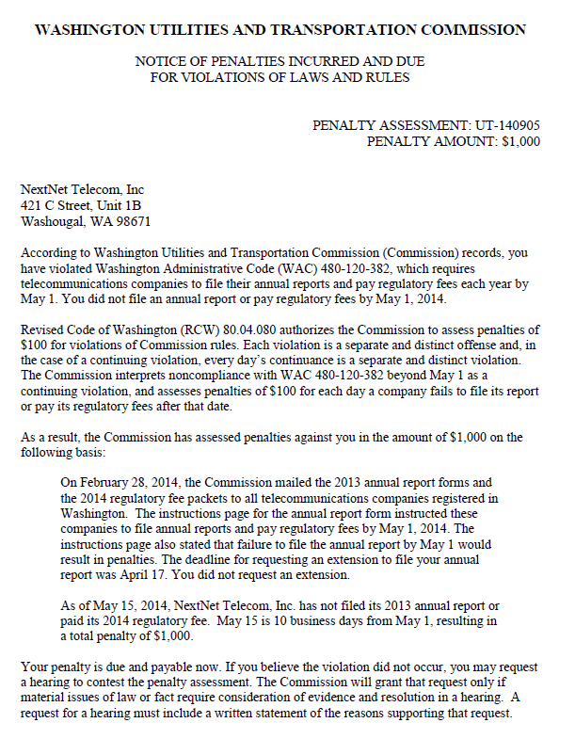

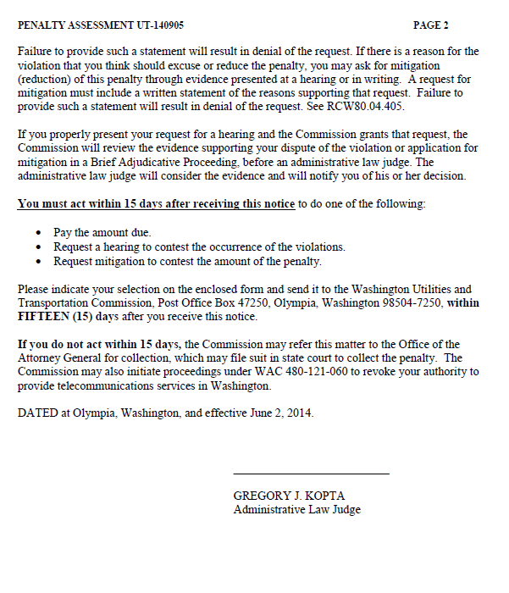

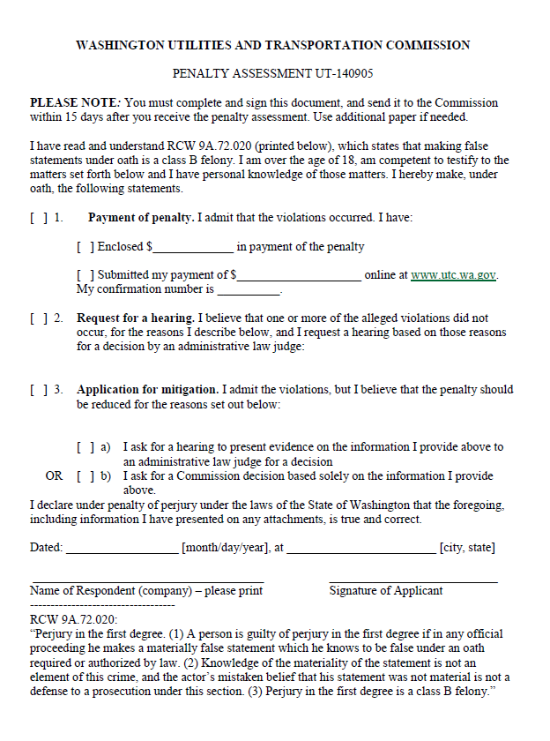

ATTACHMENT B
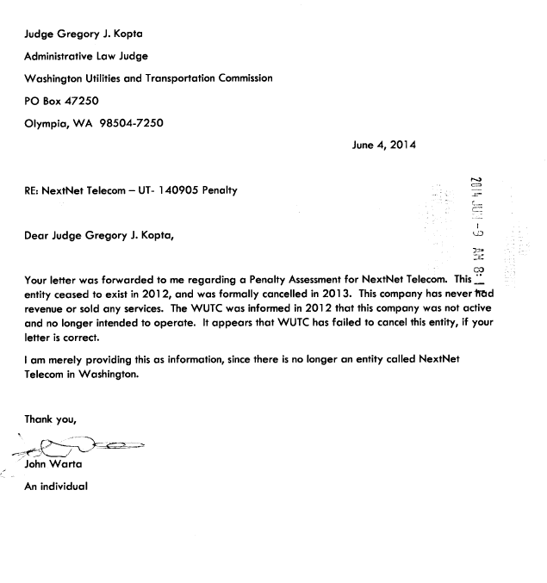

ATTACHMENT C
