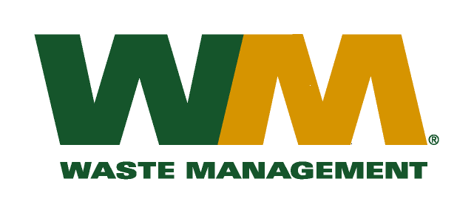

VIA EMAIL

August 31, 2016

Washington Utilities and Transportation Commission

Chandler Plaza Building

1300 S. Evergreen Park Drive SW

P.O. Box 47250

Olympia, WA. 98504-7250

Subject: Waste Management of Washington, Inc. d/b/a Waste Management of Spokane (G-237) TG-161034

This letter is to request the Commission to withdraw the filing made in the above referenced docket. The filing was made in error and we therefore respectfully ask the records center to remove the documents previously sent.

Thank you for your consideration. If you have any questions or need additional information, please contact me at:

Address: 720 4th Avenue, Suite 400, Kirkland, WA 98033

Telephone / Fax # / e-mail: (425) 814-7840 / (425) 814-7866 / [mweinstein@wm.com](mailto:mweinstein@wm.com)

Respectfully,

Michael A. Weinstein

Senior Pricing Manager, Pacific Northwest Market Area