REPORT OF THE TOLEDO TELEPHONE CO., INC. UNDER THE

WASHINGTON UNIVERSAL SERVICE COMMUNICATIONS PROGRAM

IN COMPLIANCE WITH WAC 480-123-130

June 30th, 2016

Docket No. UT-151612

File electronically

1. WAC 480-123-130(1)(a) - Access Lines Served [NECA 1.3 working loops]

January 1, 2015 December 31, 2015

Residential 1390 1454

Business 285 362

2. WAC 480-123-130(1)(b) - Use of Support

The funds received by the Company from the universal service communications program in calendar year 2015 represents monies that the Company formerly received through the Washington Exchange Carrier Association (WECA) pooling process and the reduction of support under the Federal Communications Commission’s (FCC’s) CAF ICC Program. As such, the funds from the universal service communications program contributed to the ongoing operation and maintenance expenses of the Company. The funds from the universal service communication program are contributing to the Company's ongoing provision of high-quality basic telecommunications service to customers residing in the area the Company serves.

In January 2015, the Company received $126,345 from the universal service communications program for the fiscal year ending June 30, 2015 representing the reduction in support from the CAF ICC Program.

During 2015 the Company completed a 100% fiber to the premise upgrade to our network, and was nationally recognized as the first certified gigabit provider in the state. The funds received from the universal service communications program can be viewed as contributing to the Company's ability to perform that project, including, without limitation, the repayment of loan funds.

In December 2015, the Company received $279,514 from the universal service communications program for the fiscal year ending June 30, 2016 which represents monies that the Company formerly received through the WECA pooling process and the reduction of support under the FCC’s CAF ICC Program.

During the first six months of 2016 the Company has not launched any new projects however, the funds received from the universal service communications program can be viewed as contributing to the Company's ability to perform our recent fiber upgrade, including, without limitation, the repayment of loan funds. In the second half of 2016 the Company plans to upgrade our middle mile capacity to 20 gigabits.

3. WAC 480-123-130(1)(c) - Unfilled Consumer Requests for New Basic Telecommunications Service\*

None

\* Service requests that are ongoing but still within normal processing times are not counted as unfulfilled.

4. WAC 480-123-130(1)(e) - FCC Form 477

This form was previously filed on or about March 1, 2016 under Docket UT-160032.

5. WAC 480-123-130(1)(f) - Report on Operational Efficiencies/Business Plan Modifications

The Company continually reviews its operations to determine if efficiencies can be achieved. The Company already has a plan in place to concentrate on improving broadband service while continuing to provide high-quality basic telecommunications service to the customers that are located within the area that the Company serves. The funds received from the universal communications program can be viewed as assisting in the Company's efforts to obtain operational efficiencies.

6. WAC 480-123-130(1)(g) and (h) - Other information

N/A

Certified Statement as required by WAC 480-123-130(1)(d):

I, Dale Merten am an officer of The Toledo Telephone Co., Inc., and upon personal knowledge and with responsibility therefore, hereby certify under penalty of perjury, that The Toledo Telephone Co., Inc. materially complied with Commission rules under Chapter 480-120 WAC that are applicable to the Company and its provision of service within the area for which the Company received universal service communications program support.

Signed at Toledo Washington this 30th day of June, 2016.

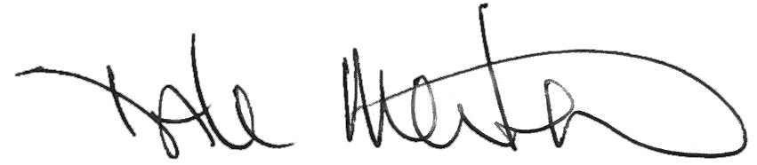

Dale Merten

C.O.O.