July 22, 2015

Mr. Steve King

Executive Director and Secretary

Washington Utilities and Transportation Commission

1300 South Evergreen Park Drive SW

Olympia, WA 98504‐7250

RE: Removing Washington Telephone Assistance Program language for Ellensburg Telephone Company d/b/a FairPoint Communications

Dear Mr. King:

On July 17, 2015, Ellensburg Telephone Company d/b/a FairPoint Communications filed tariff pages to remove WTAP language from the company’s tariff. The effective date of the change is September 1, 2015. At that time< FairPoint failed to include the following tariff page, which should also be a part of this filing.

Index Page, Second Revised Sheet 2

This filing removes Washington Telephone Assistance Program (WTAP) language from the Company’s tariff. Please also note that we are removing Tribal language as it is not appropriate for our service area. We have no tribal areas in the Ellensburg Telephone Company’s service area.

Please contact Beth Westman at 207.535.4249 or [bwestman@fairpoint.com](mailto:bwestman@fairpoint.com) with any questions or concerns regarding this filing.

Sincerely,

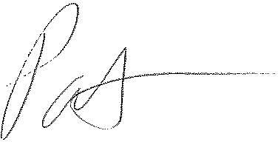

Patrick L. Morse

Senior VP Governmental Affairs

FairPoint Communications

P: 620-227-4409

F: 620-227-8576