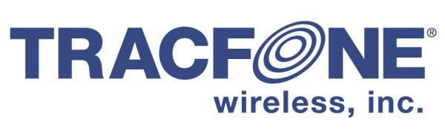

February 26, 2018

VIA ELECTRONIC FILING

Mr. Steven V. King
Executive Director and Secretary
Washington Utilities and Transportation Commission
1300 S. Evergreen Park Drive S.W.
Olympia, WA 98504-7250

Re: Terms and Conditions for Tribal Lifeline, Docket No. UT-093012

Dear Mr. King:

On December 1, 2017, the FCC released its’ Fourth Report and Order in WC Docket No. 11-42. Among other things, this order restricted Enhanced Lifeline Support on Tribal Lands to facilities based providers. Accordingly, TracFone has terminated new enrollments into its Tribal Lifeline program. The following terms and conditions will apply to the small number of customers still enrolled in that program, until August 1, 2018, or such other time as the new limitation takes effect.

“Residents of Tribal Lands are eligible for additional Lifeline discounts. For purposes of the LifeLine Program, the term “Tribal Lands” includes any Federally recognized Indian Tribe reservation, pueblo, or colony, including former reservations in Oklahoma, Alaska Native regions established pursuant to the Alaska Native Claims Settlement Act (85 Stat. 688), Indian allotments, and Hawaiian Home Lands. Customers qualifying as eligible residents of Tribal Lands will receive unlimited airtime and text messages, as well as 3GB of data each month.”

If you have any questions, please feel free to contact me at (305) 715-3613, or sathanson@tracfone.com.

Sincerely,

Stephen Athanson

